Arquitetura Oracle
terça-feira, 11 de abril de 2017
20:52
https://docs.oracle.com/en/database/oracle/oracle-database/26/dbiad/all_diagrams.html

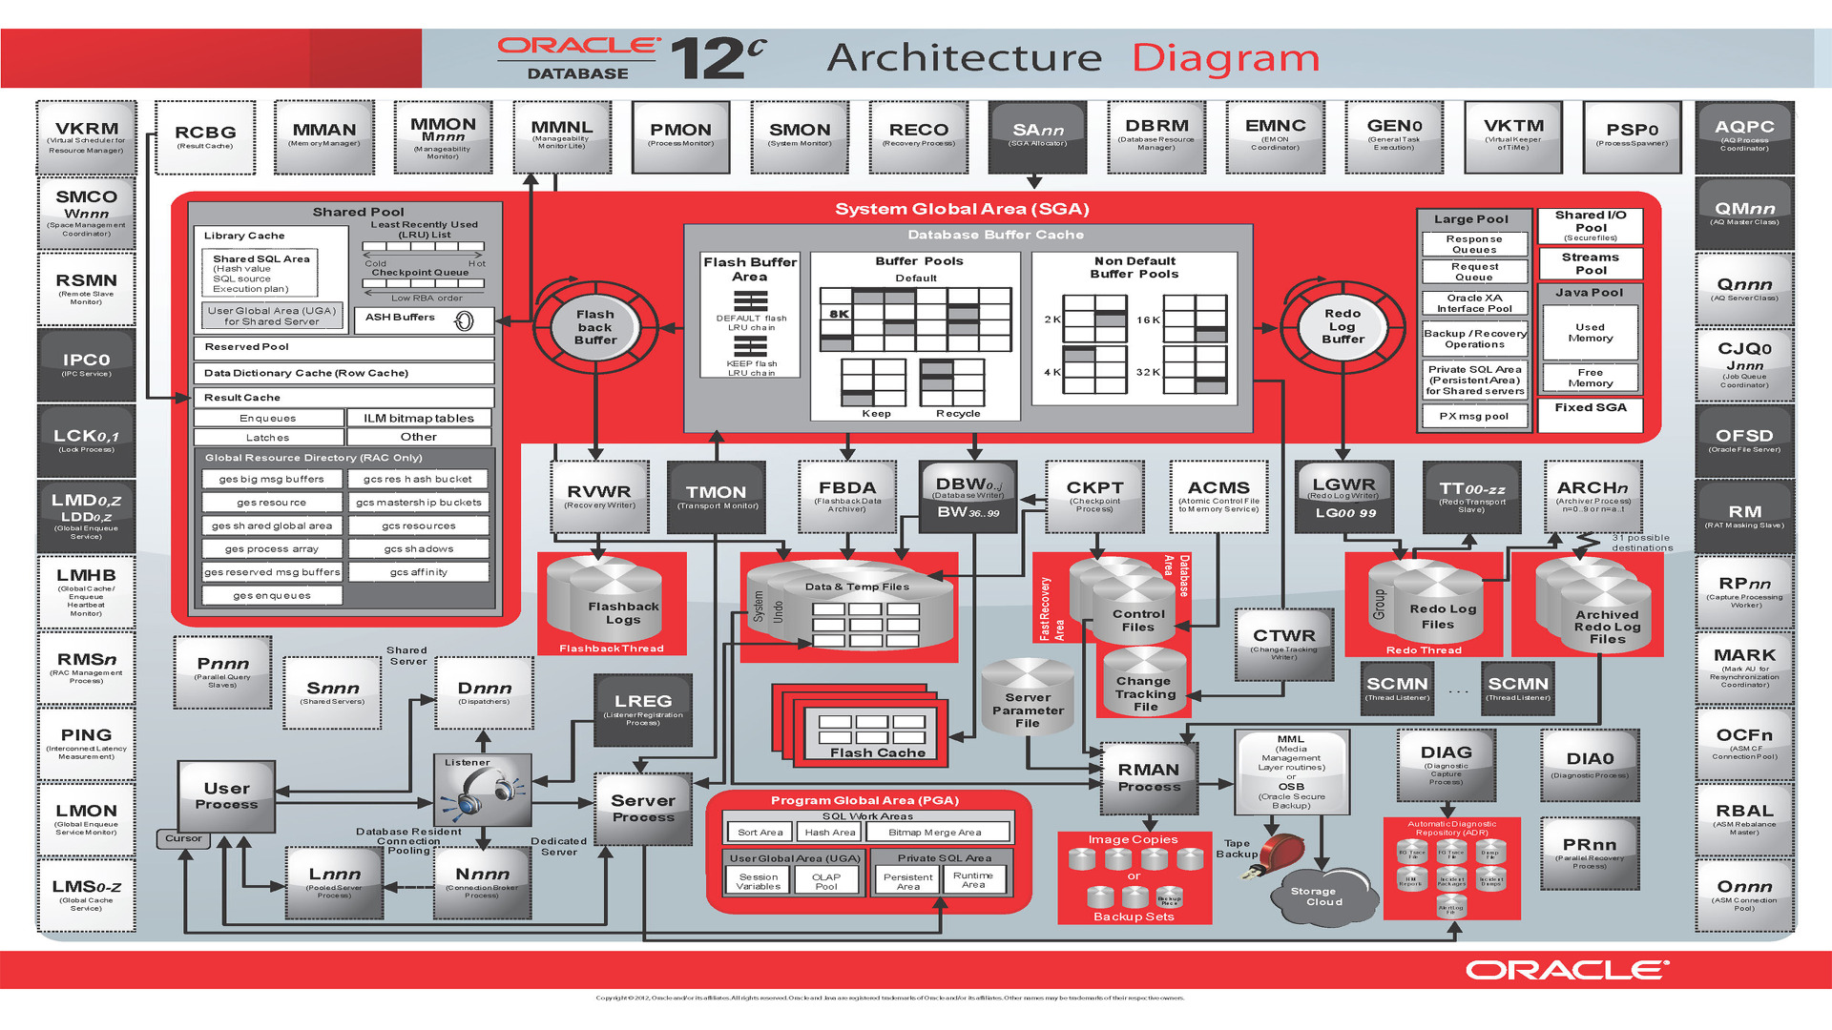

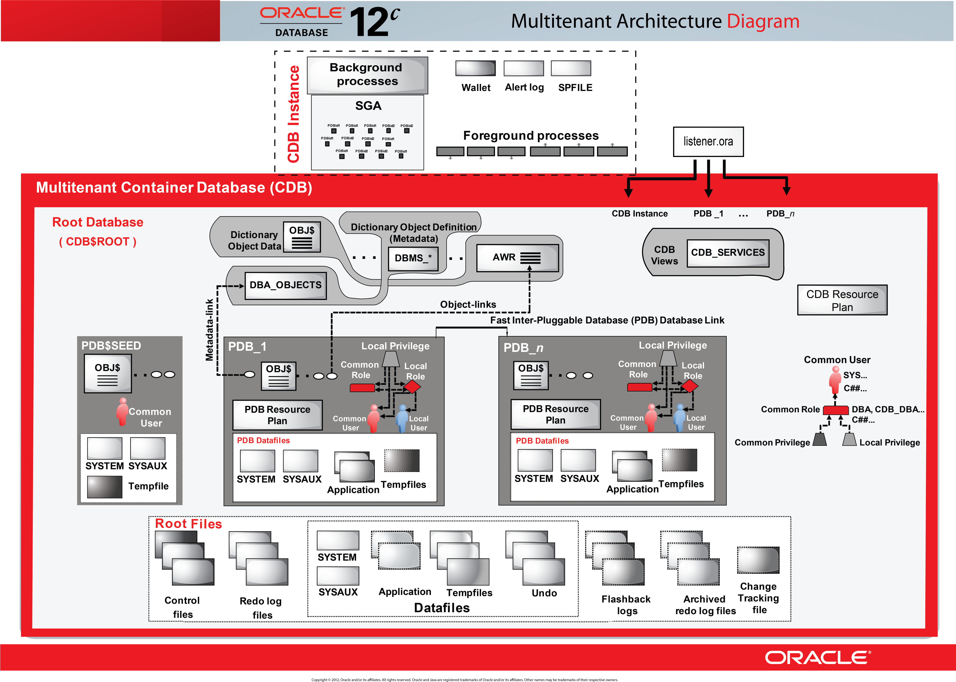
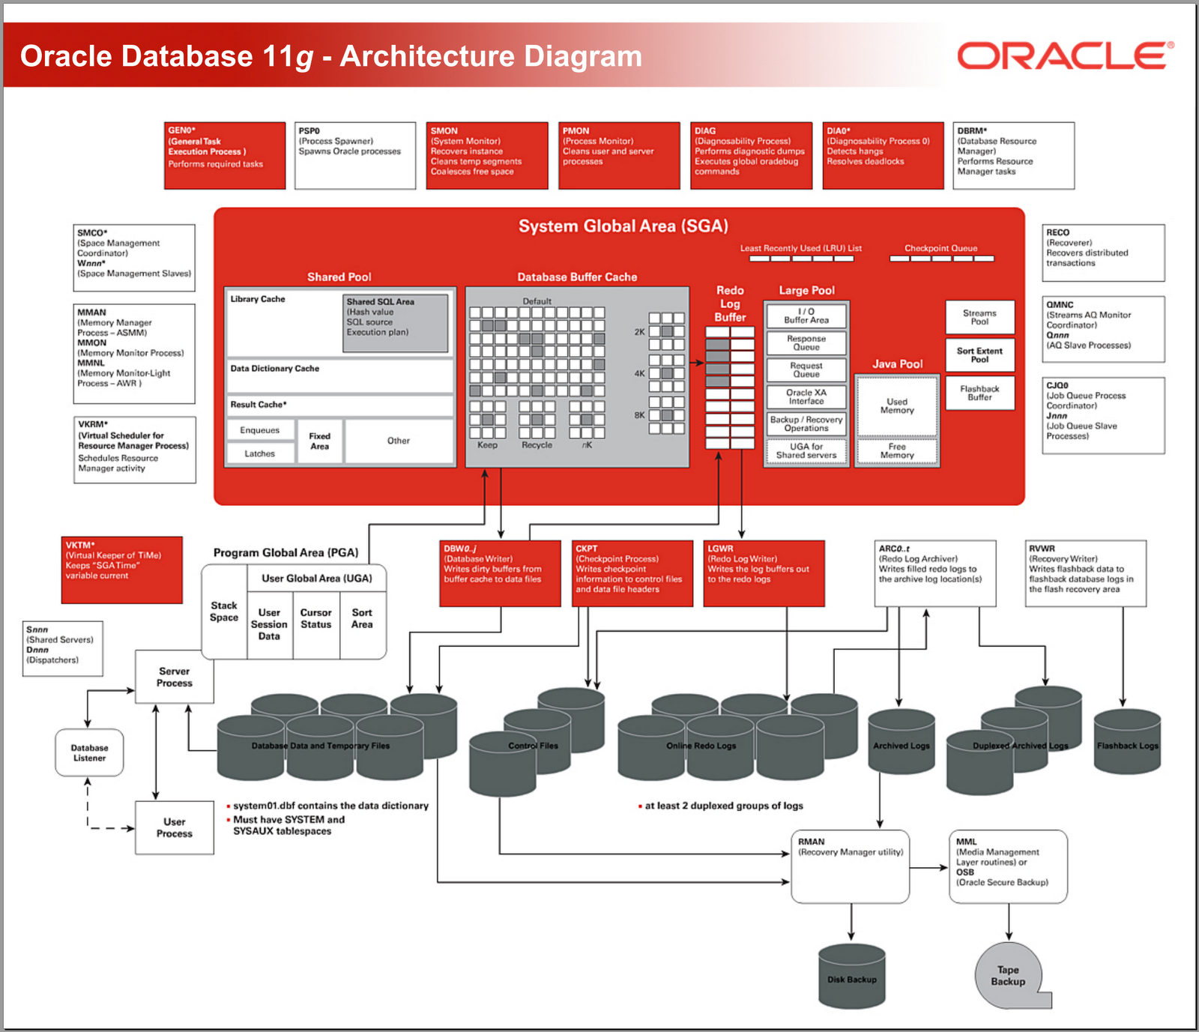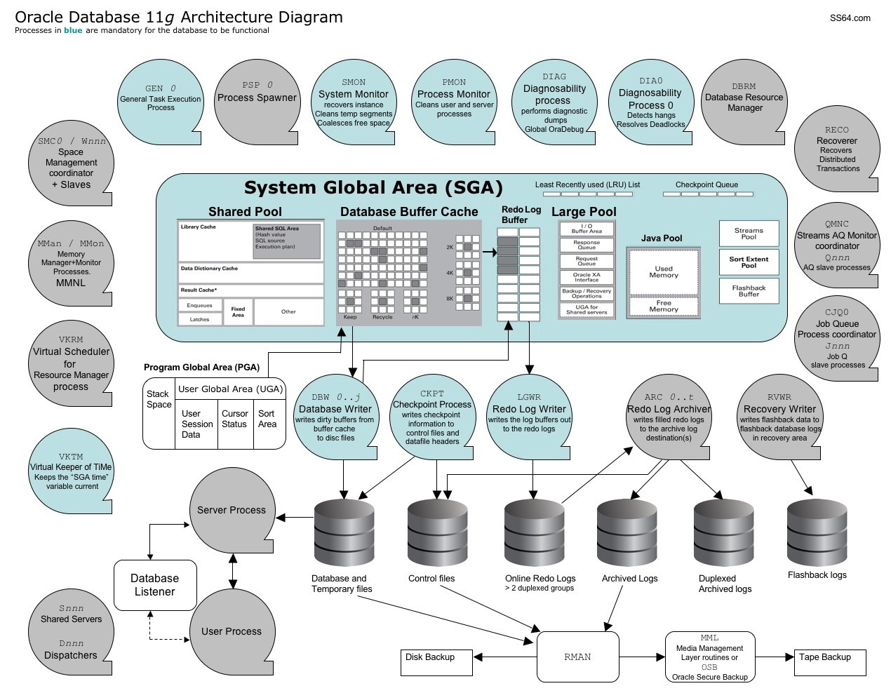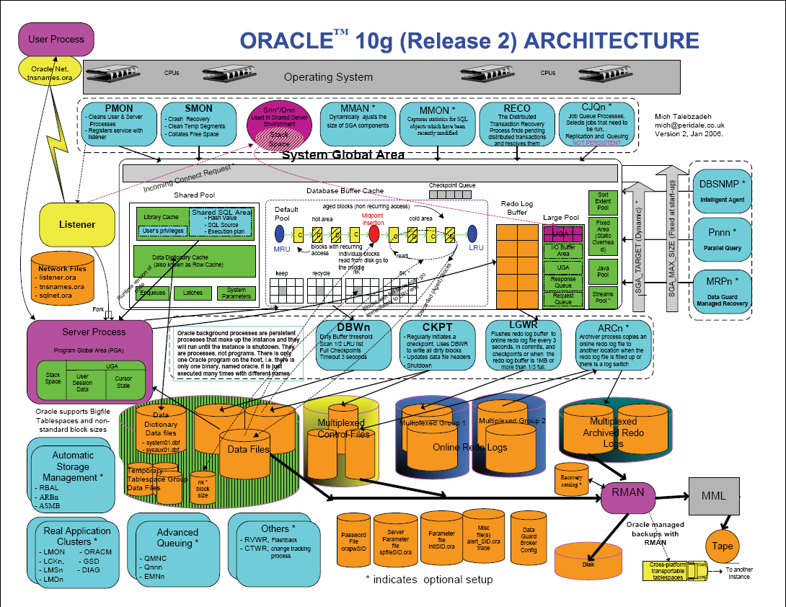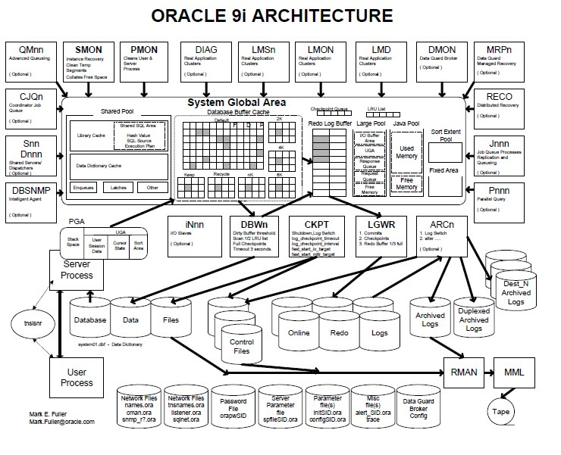

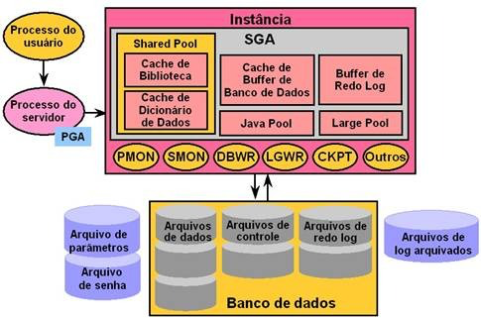

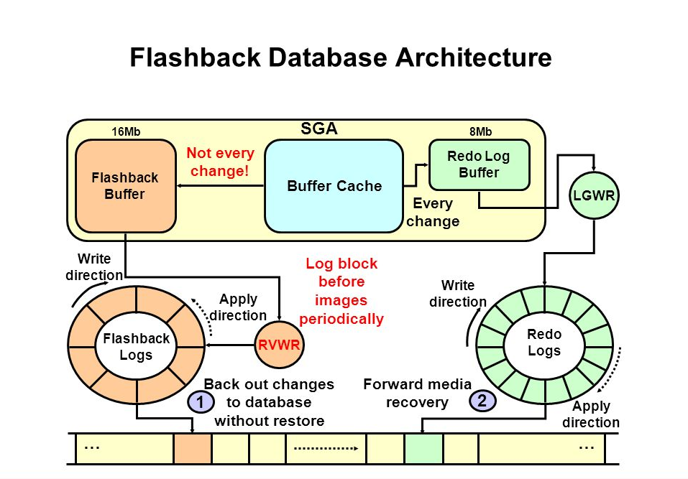

PMON
The process monitor manages the system’s server
processes. It cleans up failed processes by releasing resources and
rolling back uncommitted data.
SMON
The system monitor is primarily responsible for instance
recovery. If the database crashes and redo information must be read
and applied, the SMON takes care of it. It also cleans and releases
temporary space.
DBWn
The database writer’s sole job is taking dirty
blocks from the dirty list and writing them to disk. There can be
up to 20 of them, hence the n. It starts as DBW0 and
continues with DBW1, DBW2, and so on. After DBW9, it continues with
DBWa through DBWj. An average system won’t see more than a
few of these.
LGWR
The log writer process flushes the redo log buffer. It
writes the redo entries to disk and signals a completion.
CKPT
The checkpoint process is responsible for initiating
check points. A check point is when the system periodically dumps
all the dirty buffers to disk. Most commonly, this occurs when the
database receives a shutdown command. It also updates the data file
headers and the control files with the check point information so
the SMON know where to start recovery in the event of a system
crash.
ARCn
Up to 30 archiver processes (0–9, a–t) are
responsible for copying filled redo logs to the archived redo
storage area. If your database isn’t running in archive mode,
this process shuts down.
CJQ0
The job queue coordinator checks for scheduled tasks
within the database. These jobs can be set up by the user or can be
internal jobs for maintenance. When it finds a job that must be run
it spawns the following goodie.
J000
A job queue process slave actually runs the job. There
can be up to 1,000 of them (000–999).
DIA0
The diagnosability process resolves deadlock situations
and investigates hanging issues.
VKTM
The virtual keeper of time sounds like a fantasy game
character but simply provides a time reference within the
database.
LREG
The listener registration process, which registers
database instance and dispatcher information with the Oracle
listener process. This allows incoming user connections to get from
the listener to the database.
MMON
The manageablity monitor process supports the Automatic
Workload Repository (AWR) by capturing statistics, monitoring
threasholds, and taking snapshots. This is related to performance
tuning and troubleshooting.
MMNL
The manageability monitor lite’s job is to write
Active Session History (ASH) statistics from ASH buffer in the SGA
to disk. This is related to performance tuning and
troubleshooting

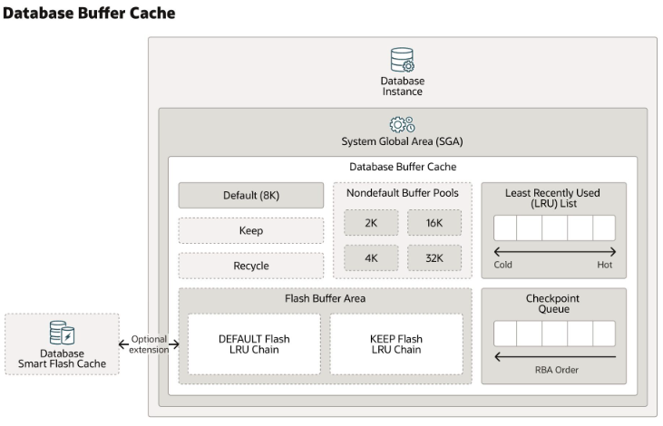

Entendendo a execução dos comandos SQL (avançado):

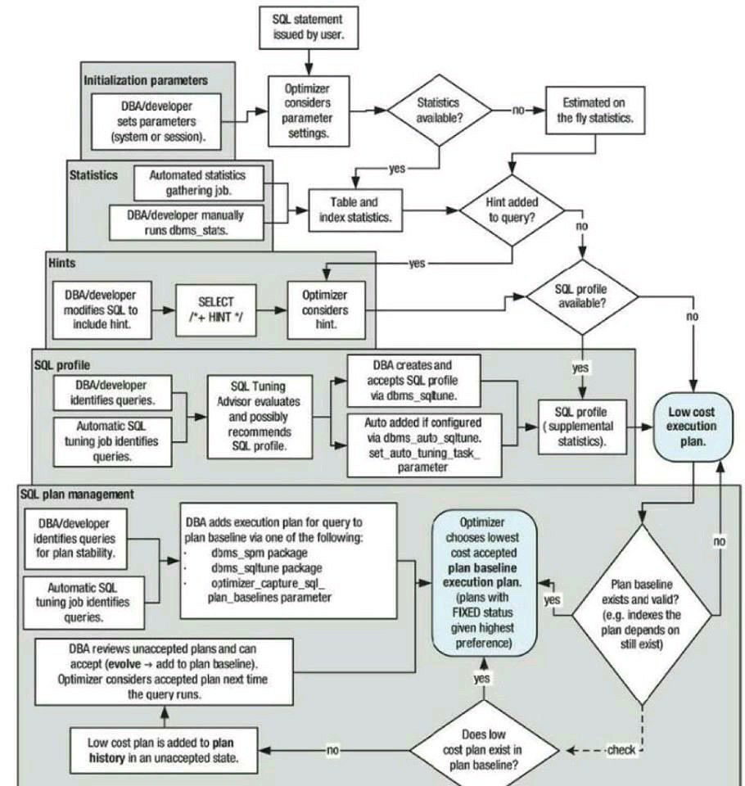
Entendendo o processamento de querys PARSE (basic):
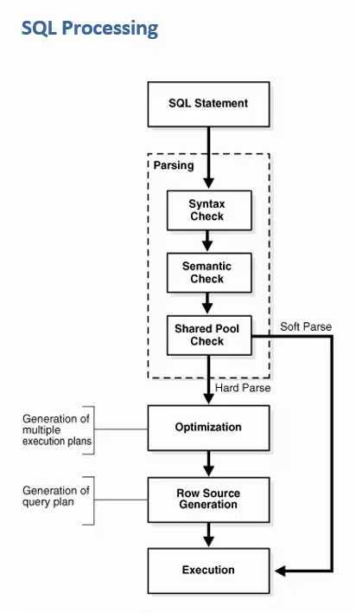

ASM Architecture:

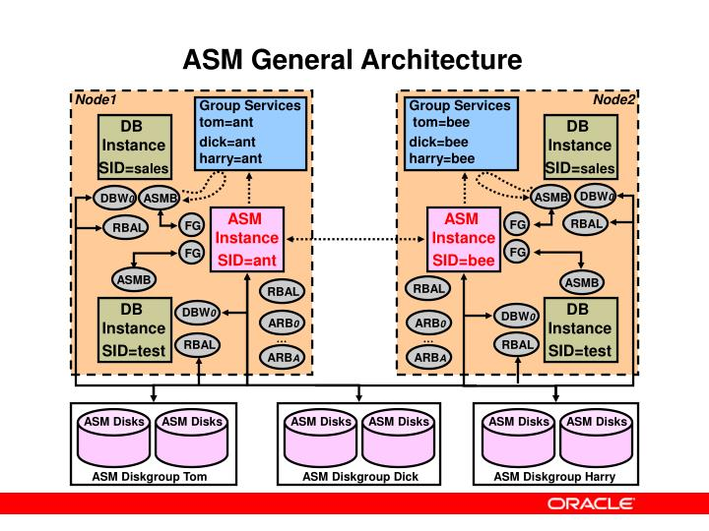

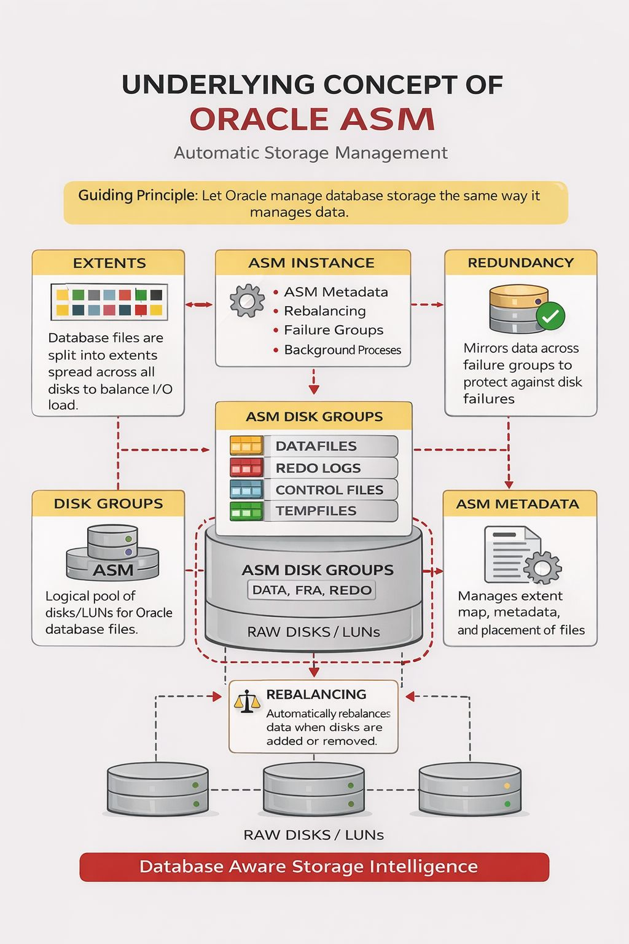

In Oracle RAC environments, storage must be shared, resilient, and cluster-aware.
This is exactly why Oracle ASM (Automatic Storage Management) is the preferred choice for RAC deployments.
🔹 Why ASM Is Ideal for Oracle RAC
✅ Cluster-Aware Storage
ASM natively understands RAC architecture, allowing all nodes to access the same disk groups safely and efficiently.
✅ Automatic I/O Load Balancing
ASM stripes data across all disks, eliminating hotspots and improving RAC performance.
✅ High Availability with Redundancy
Supports NORMAL and HIGH redundancy, protecting RAC databases from disk failures.
✅ Online Storage Management
Disks can be added or removed without downtime—ASM automatically rebalances data across nodes.
✅ Simplified Administration
No manual file naming or mount point management—ASM reduces DBA operational overhead.
✅ Seamless Integration with RAC Services
ASM works tightly with Clusterware, ensuring consistent storage availability across nodes.
For Oracle RAC, ASM is not just storage—it’s an availability and performance enabler.
A well-managed RAC environment starts with a well-designed ASM architecture.

How ASM Works (Conceptually)
🔸 Disk Groups Instead of File Systems
ASM groups raw disks or LUNs into disk groups (DATA, FRA, REDO).
Oracle sees storage as a logical pool, not individual disks.
🔸 Extent-Based Storage Management
Database files are broken into extents and evenly distributed across all disks.
This enables automatic striping and balanced I/O.
🔸 ASM Metadata Management
ASM internally tracks where every extent resides — no OS-level file names required.
🔸 Redundancy & Mirroring
ASM provides NORMAL / HIGH redundancy, mirroring extents across failure groups to protect against disk failures.
🔸 Rebalancing
When disks are added or removed, ASM automatically rebalances extents online, without database downtime.
🔹 Why This Concept Matters in RAC
✔ All RAC nodes access the same disk groups safely
✔ No single disk becomes a performance bottleneck
✔ Storage changes do not disrupt cluster operations
✔ Consistent performance across nodes

ASM abstracts storage complexity and delivers performance, availability, and scalability by design.
It’s not just storage management — it’s database-aware storage intelligence.
Oracle RAC Architecture:

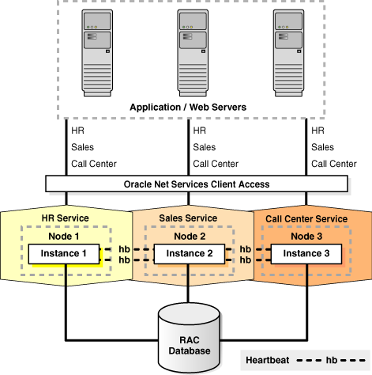
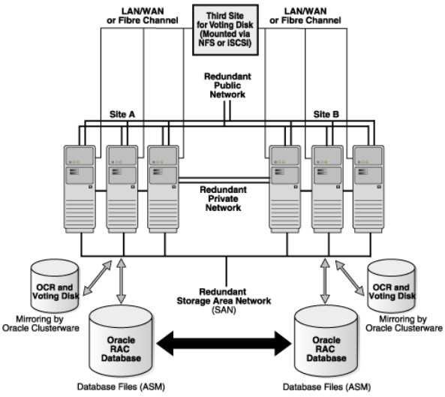
Clusteware startup sequence

  - 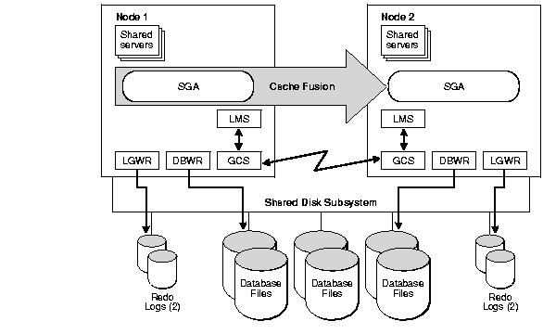

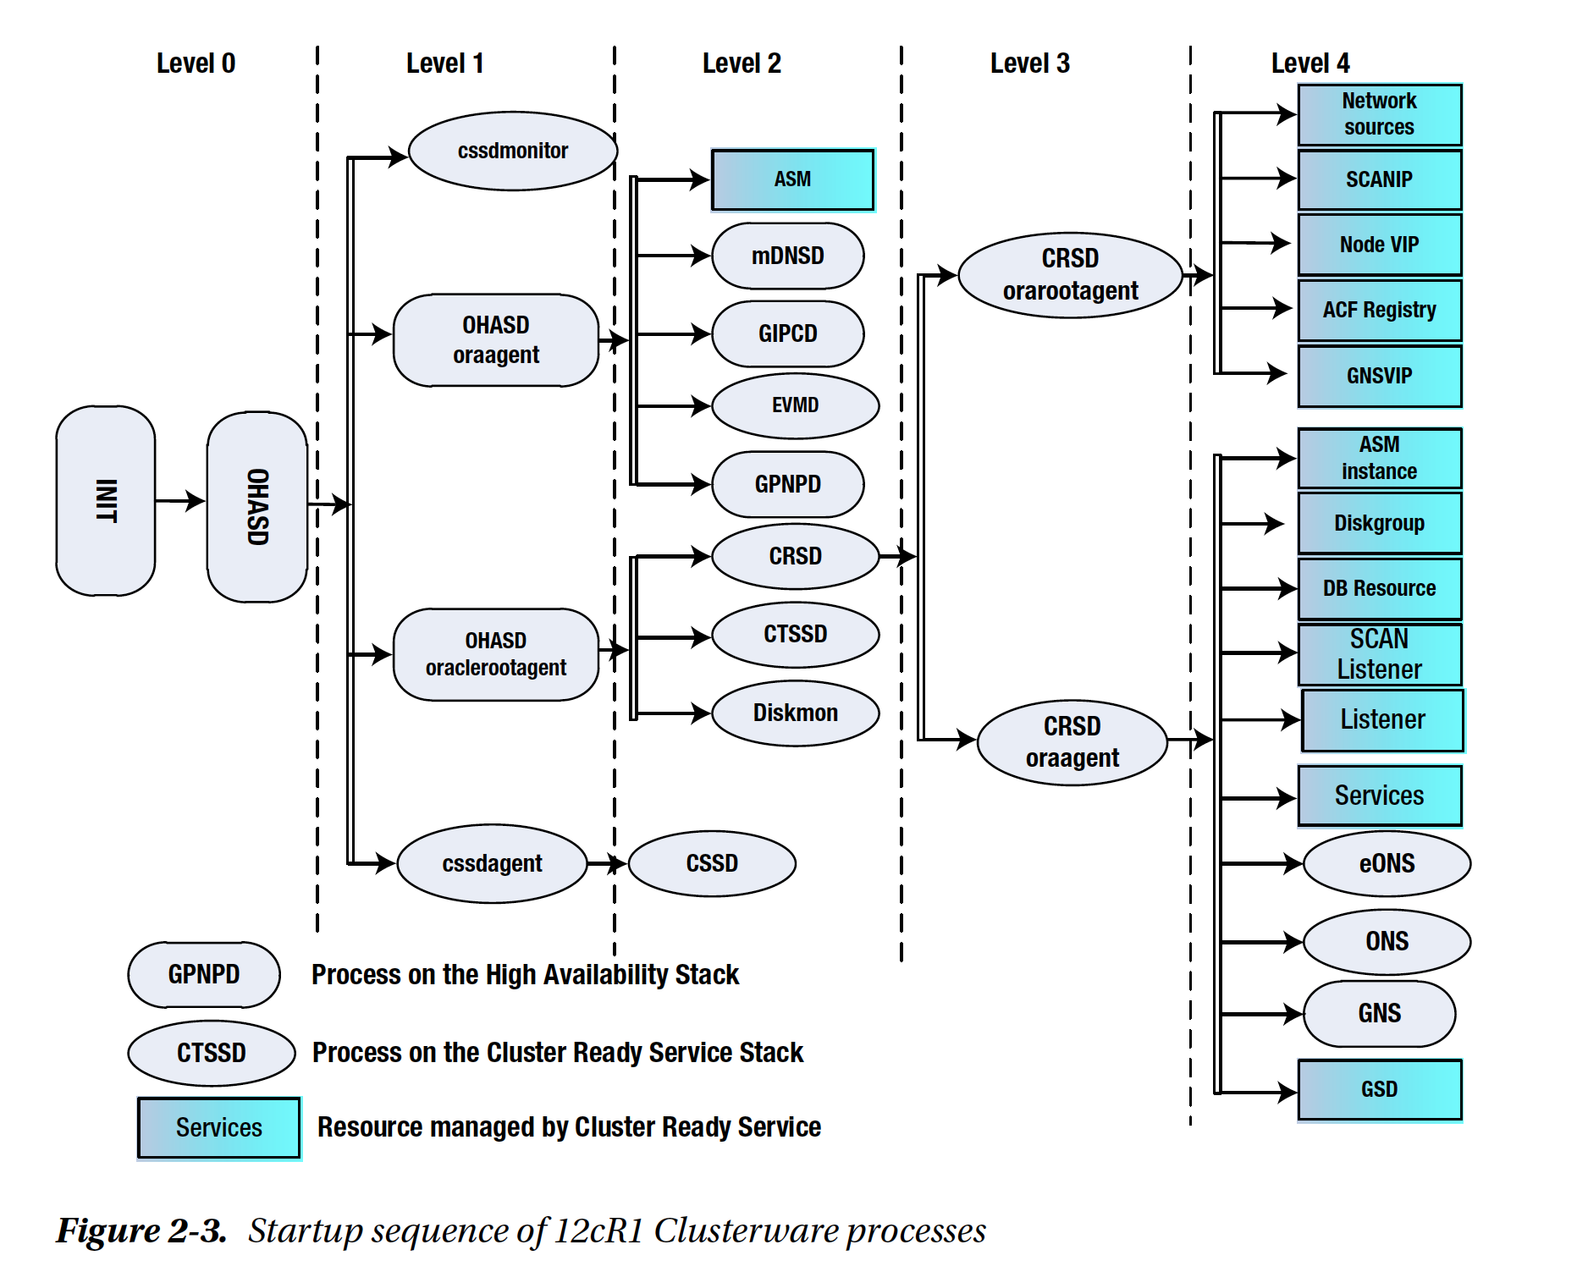

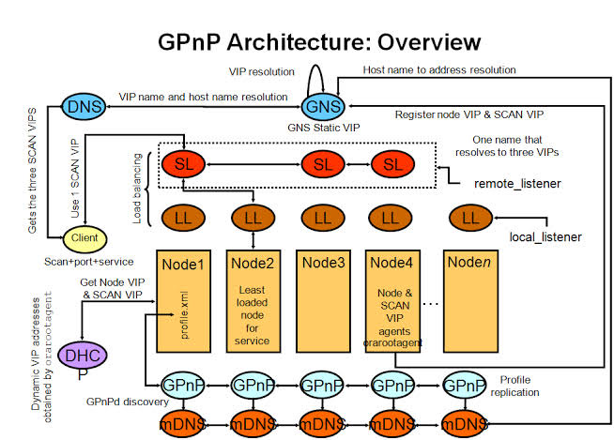

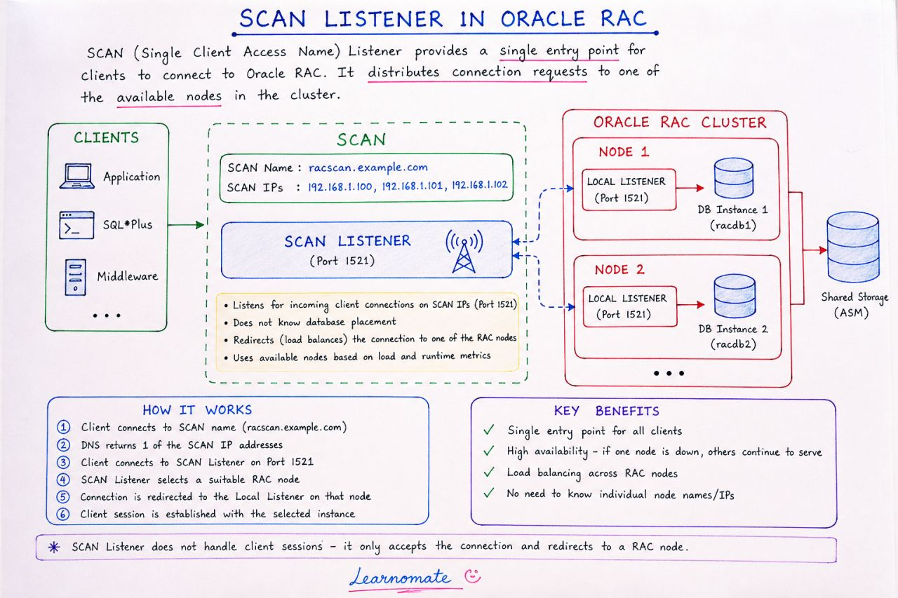
Oracle Dataguard Architecture:
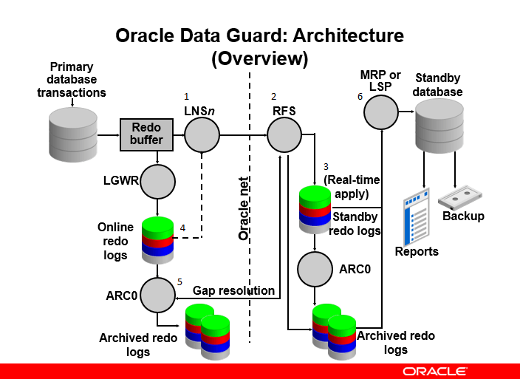

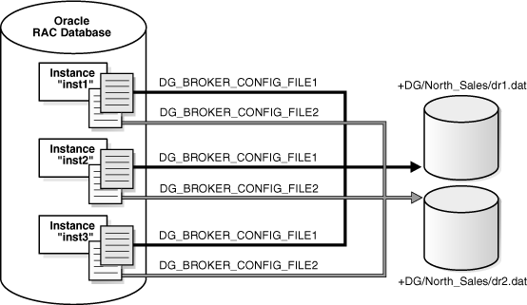

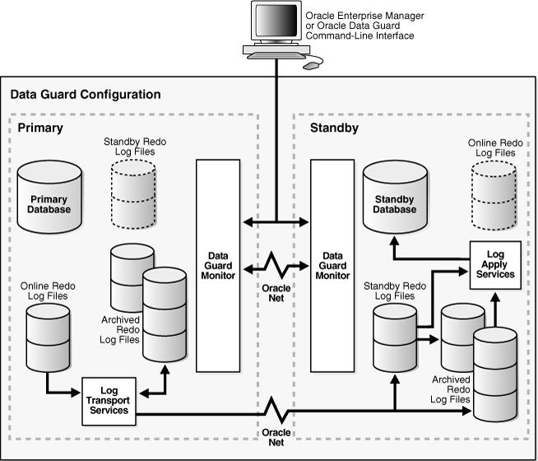

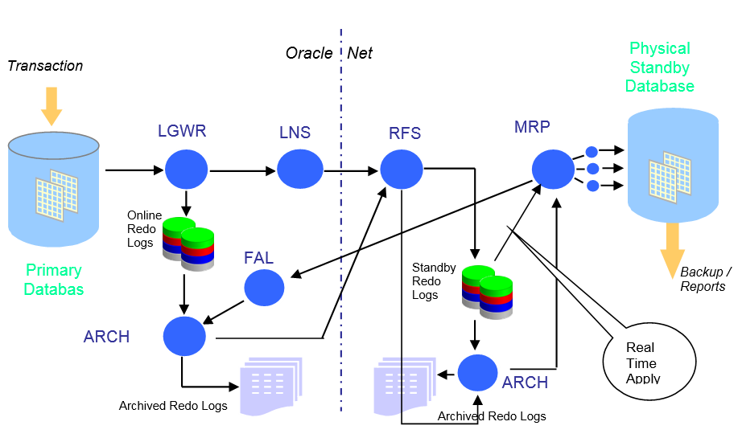
CDB Architecture:
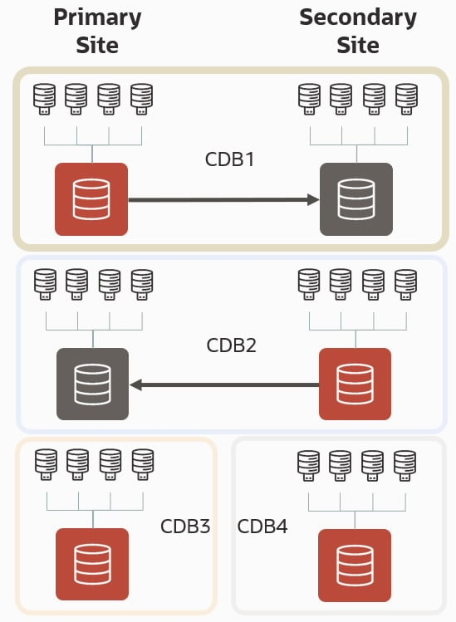

PDB Architecture
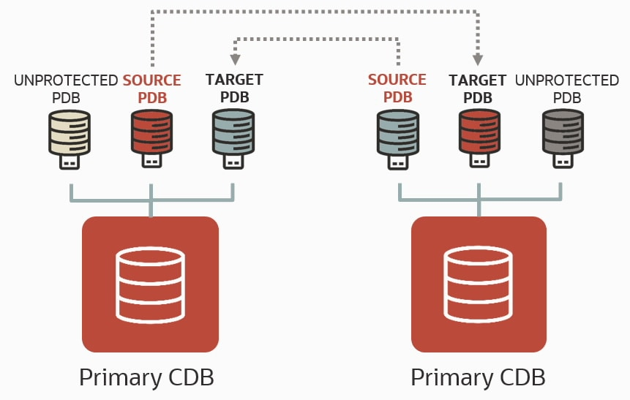

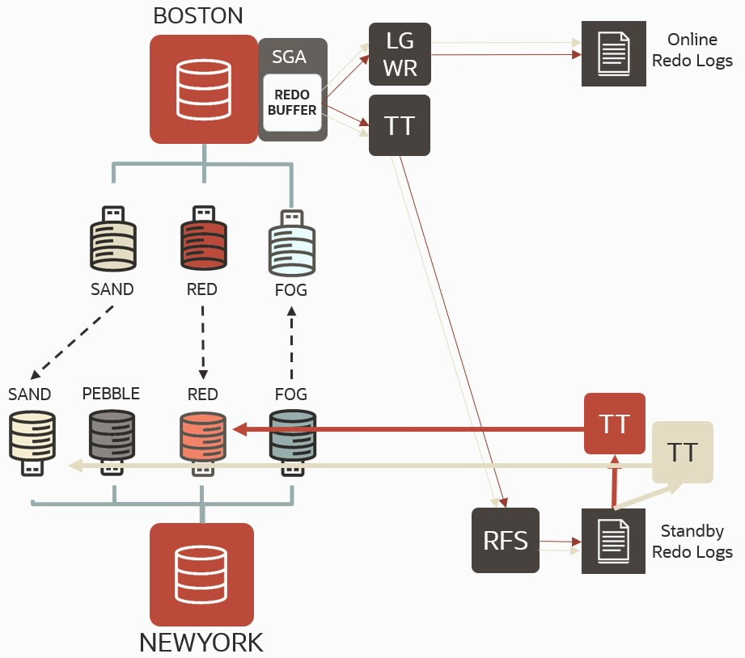

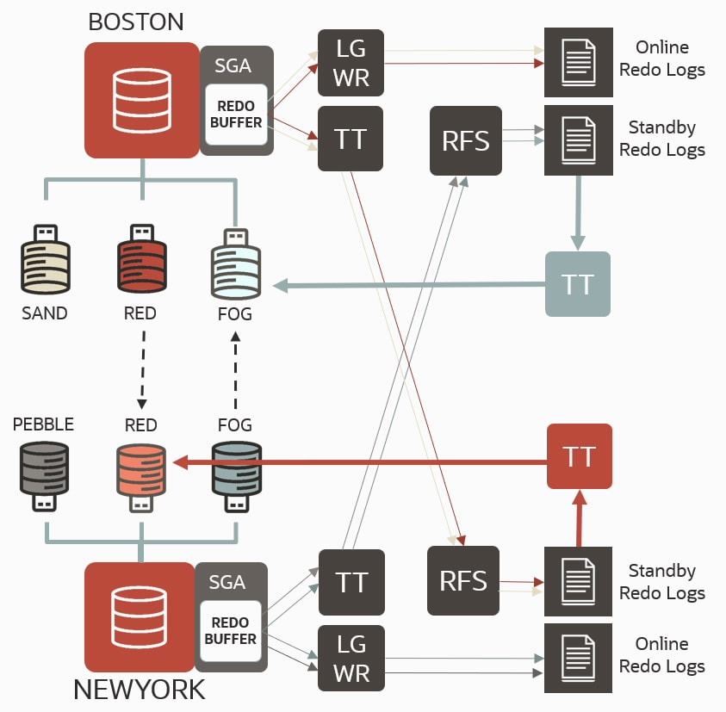

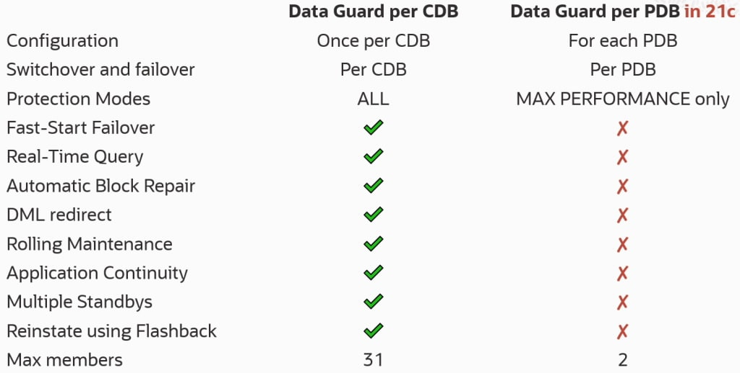
https://docs.oracle.com/en/database/oracle/oracle-database/21/dgbkr/examples-using-data-guard-broker-dgpdb-DGMGRL-utility.html#GUID-A4A551E3-0CB4-41DB-8CC0-FBE1E836D311
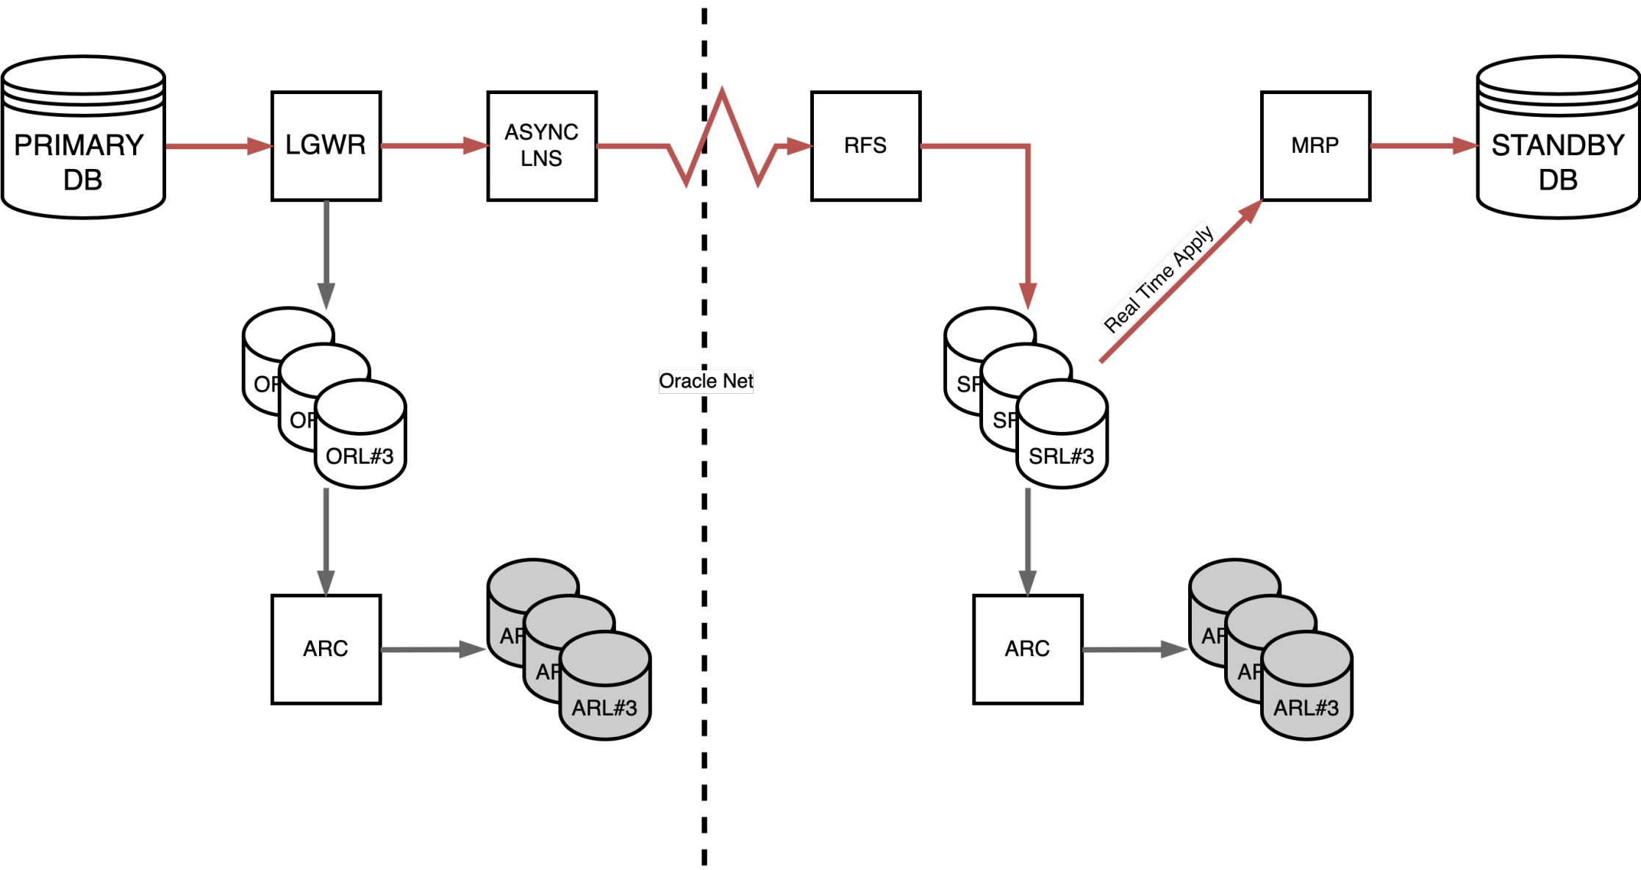

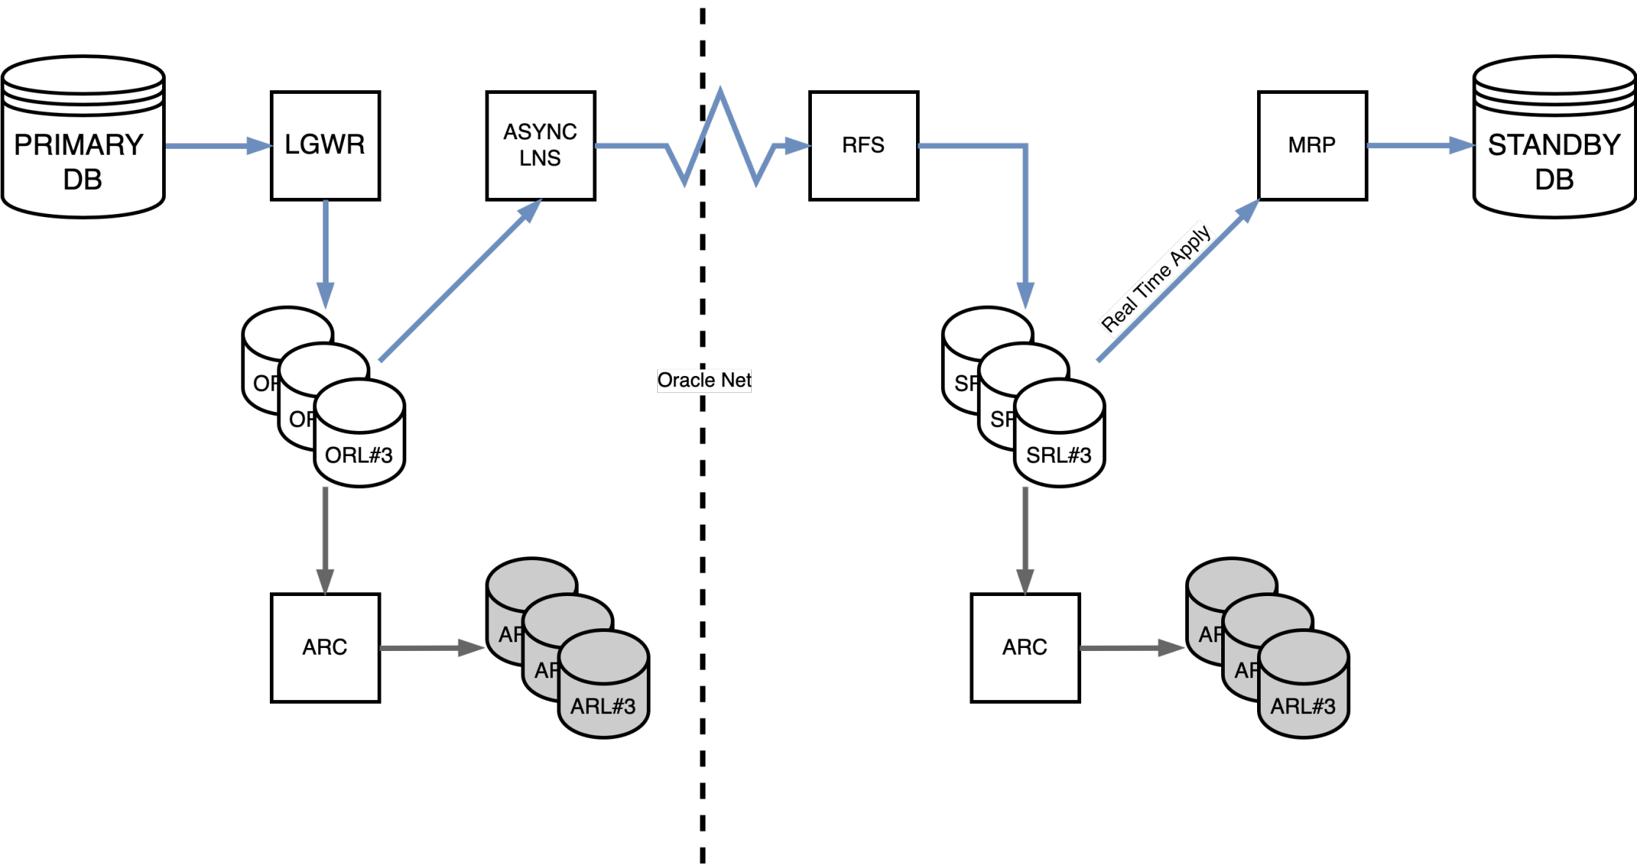

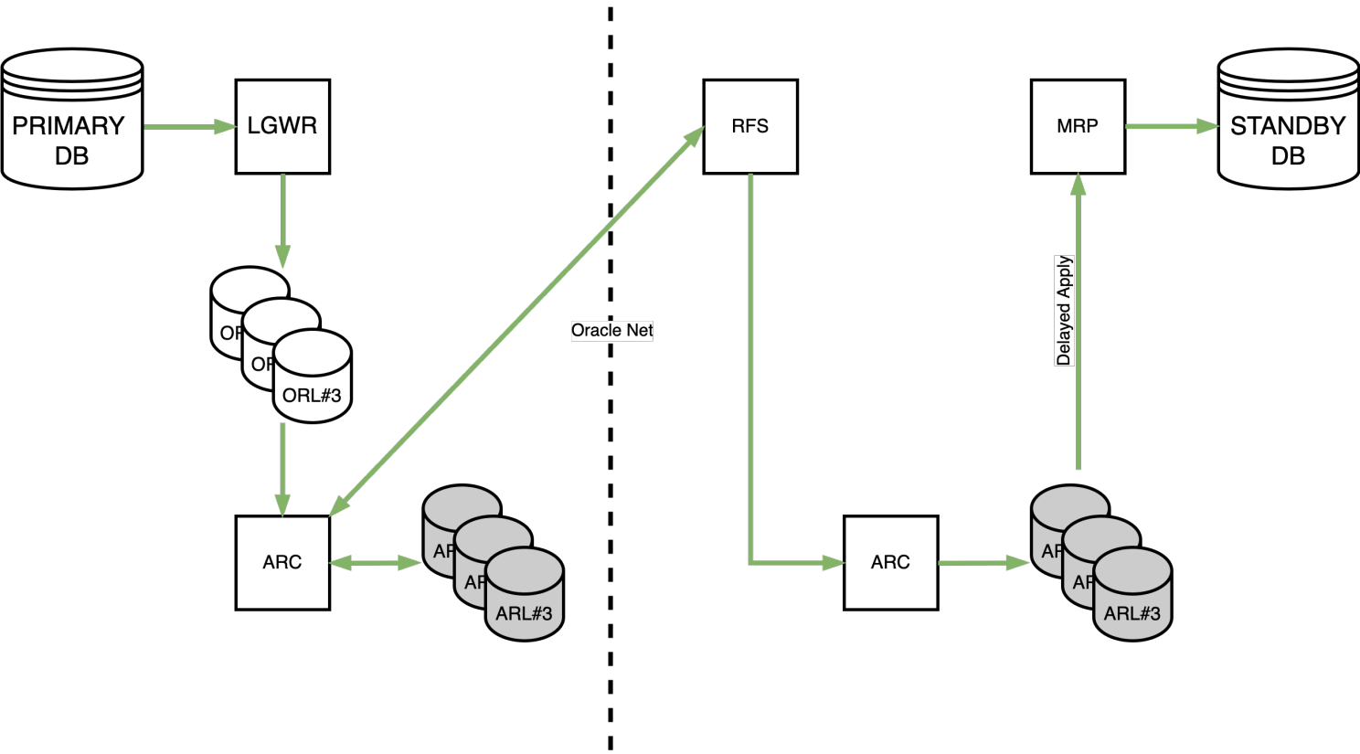

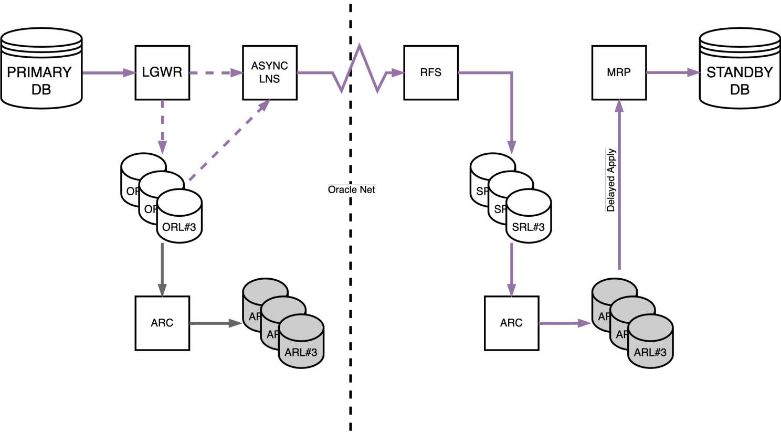
Far Sync Architecture Overview

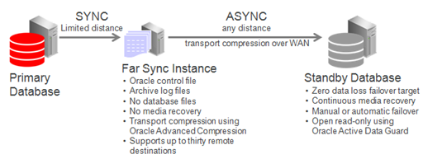
Role Transition Facilitated by Far Sync

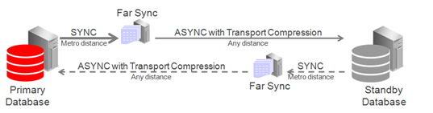
Far Sync Ships Redo to Reader Farm

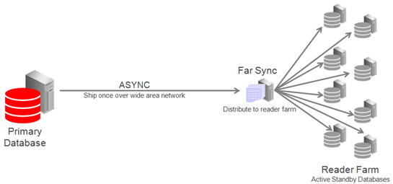
Far Sync Hub Architecture

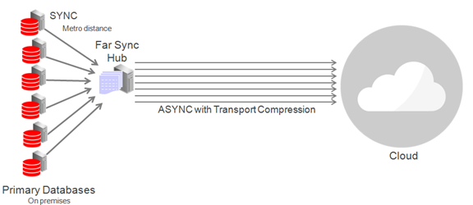
DG Redo cascadinh

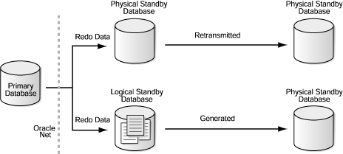
Golden Gate Architecture:

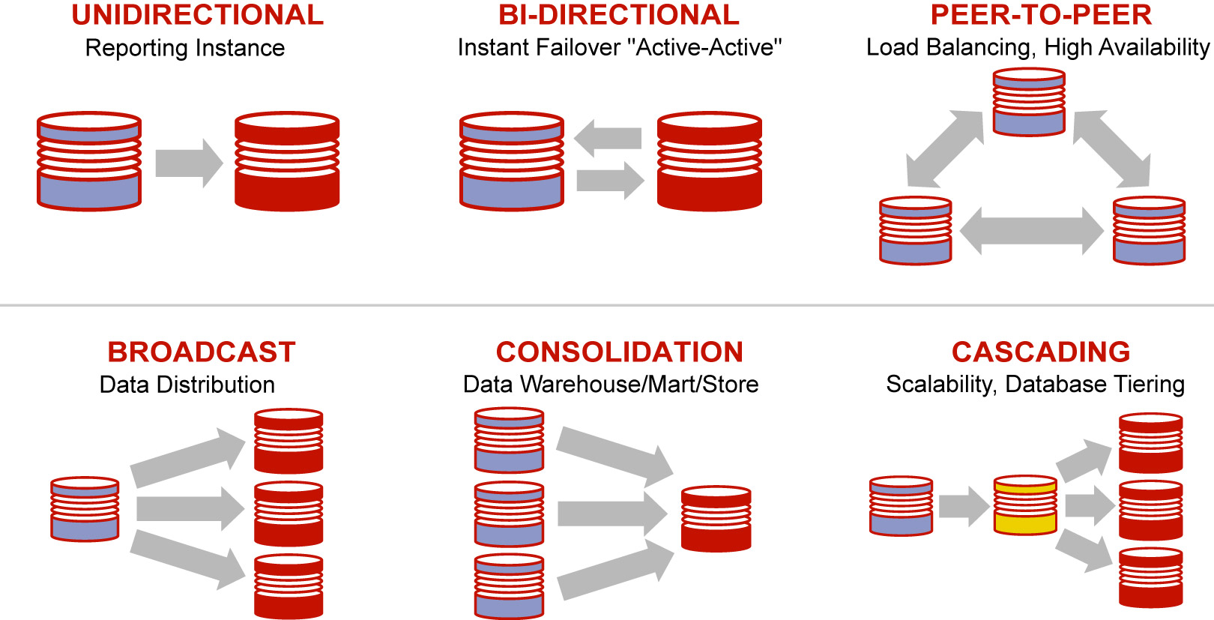

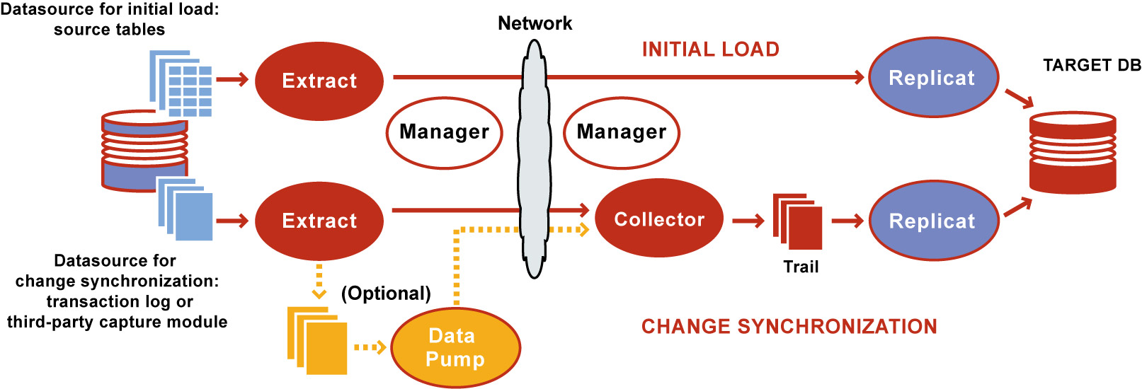

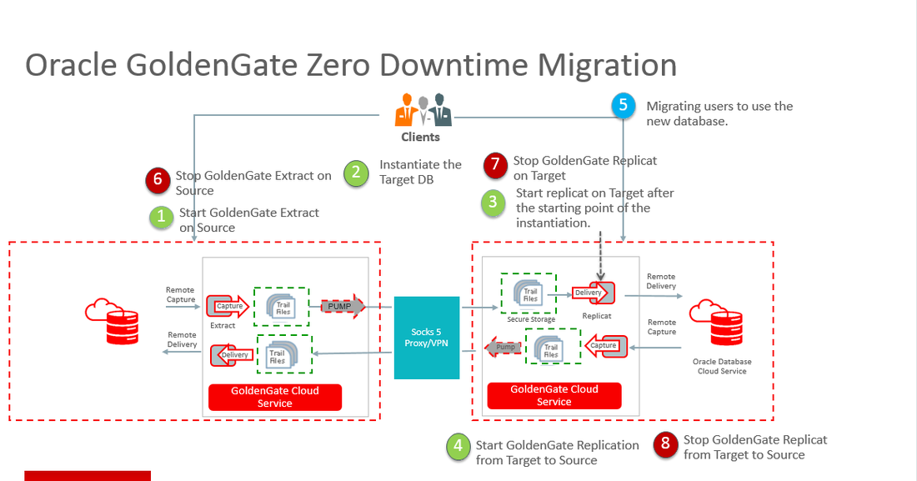
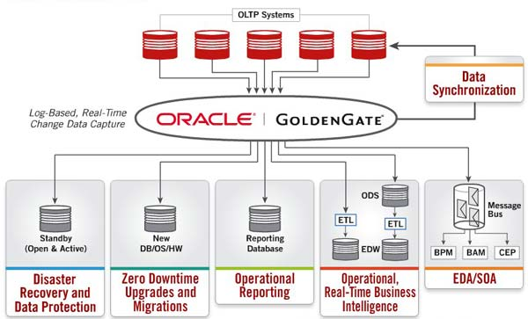

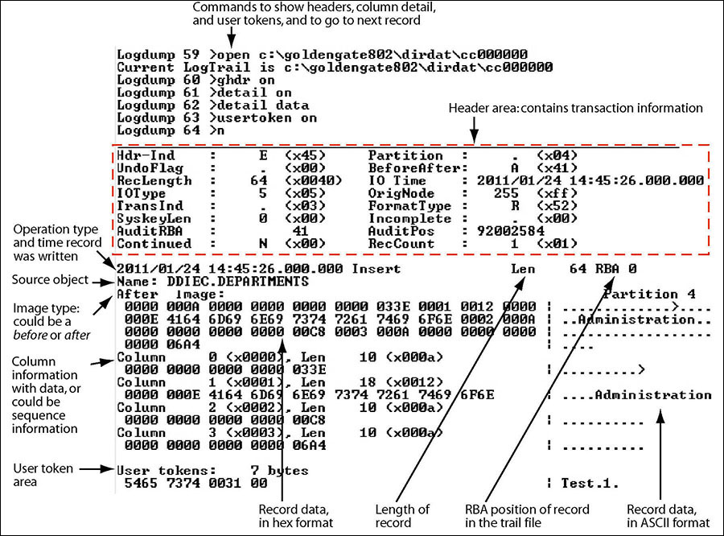
https://alexlima.com/2025/09/13/unlocking-oracle-goldengate-logdump-beyond-the-basics/

Maximum availability Architecture:
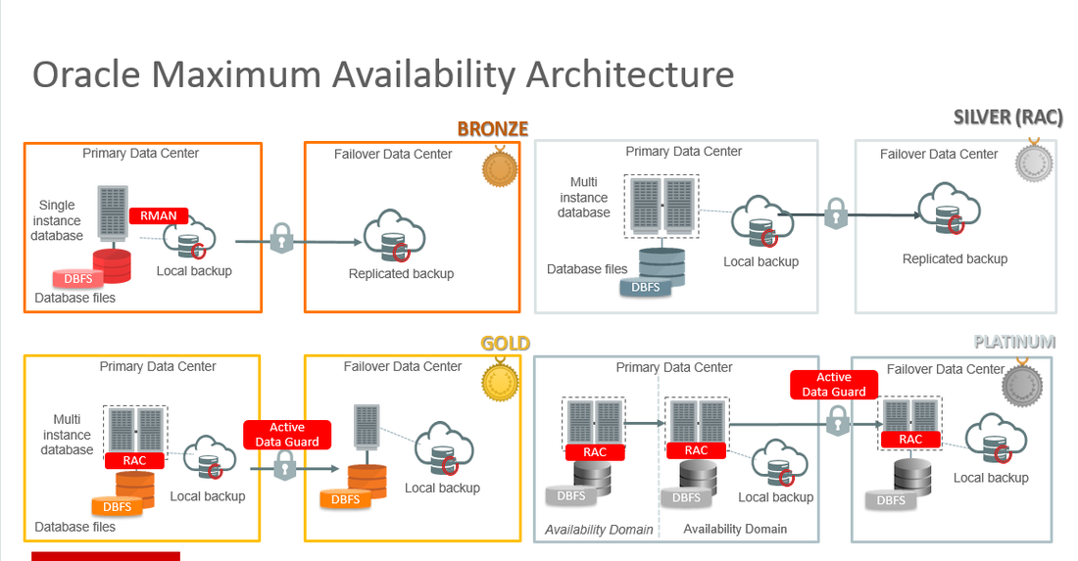
Oracle cloud Architecture - Logical view:
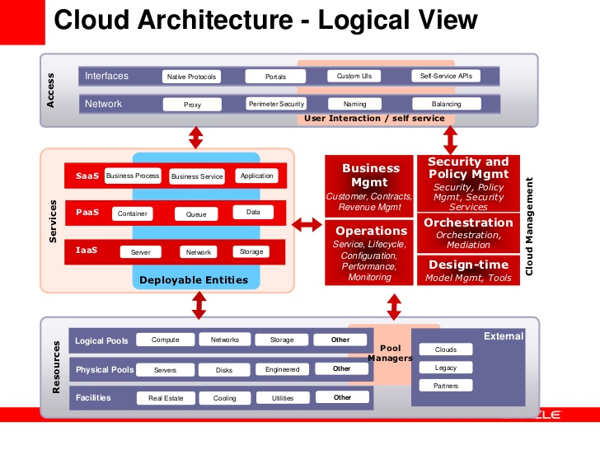
Exatadata Architecture:
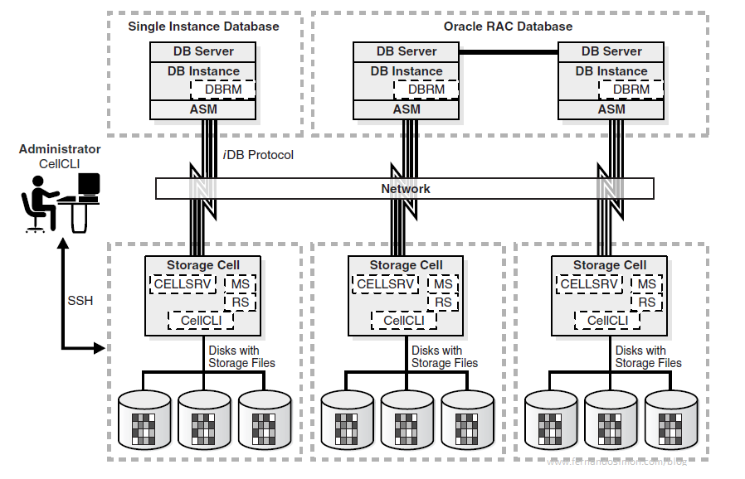
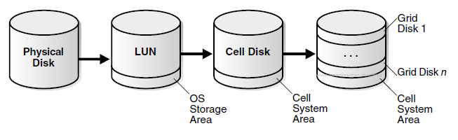

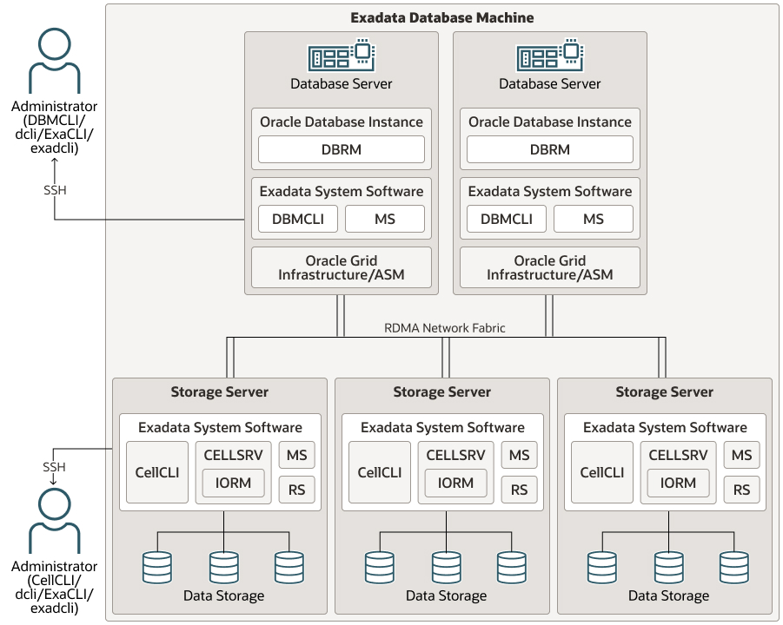

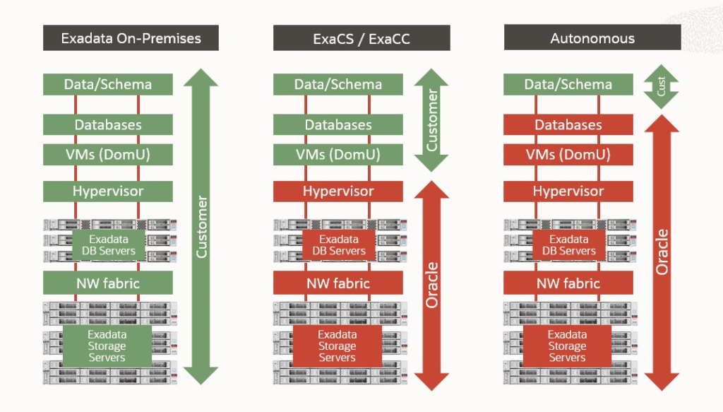

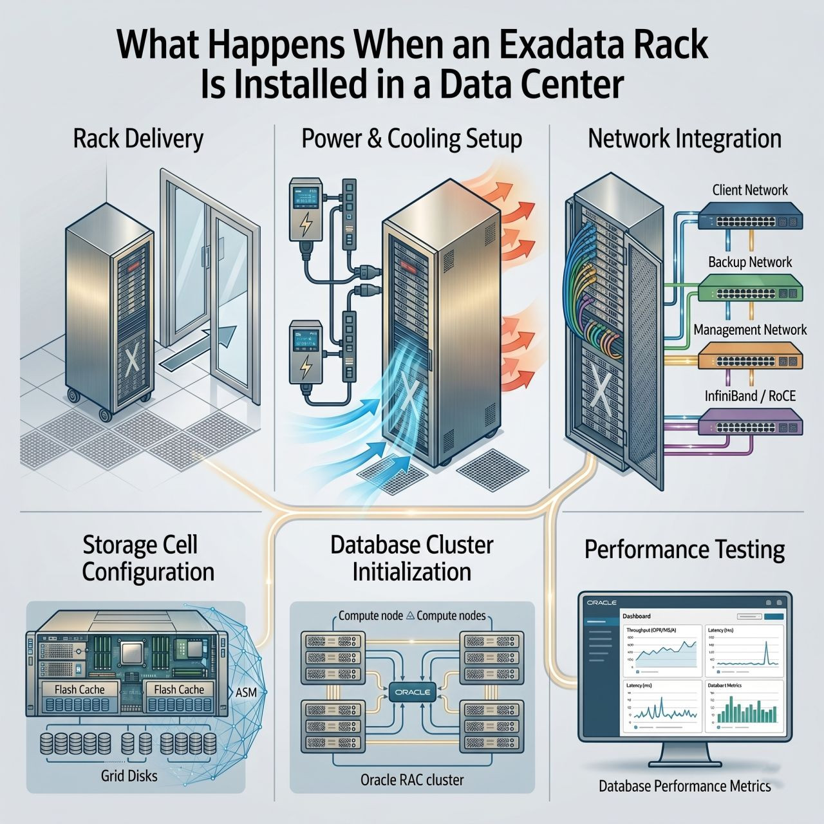

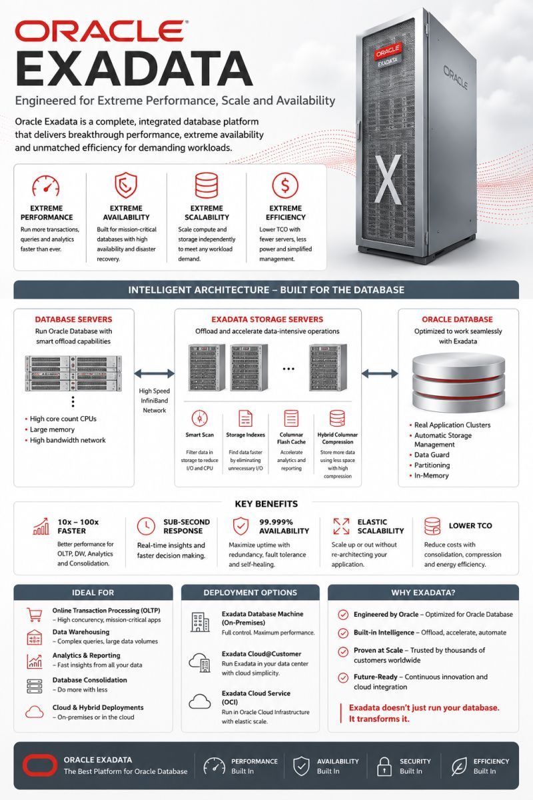

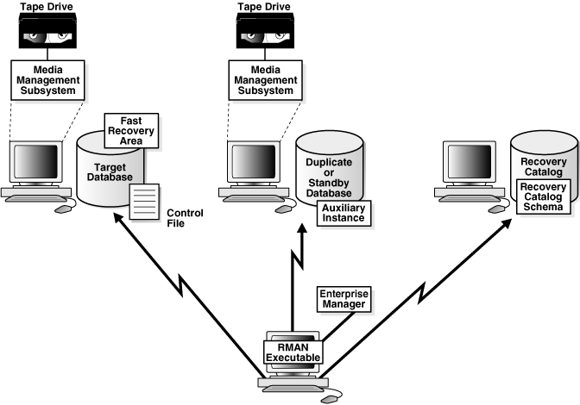

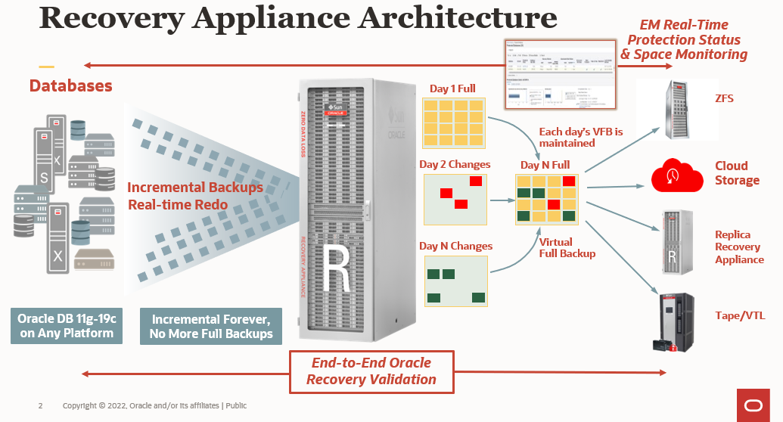

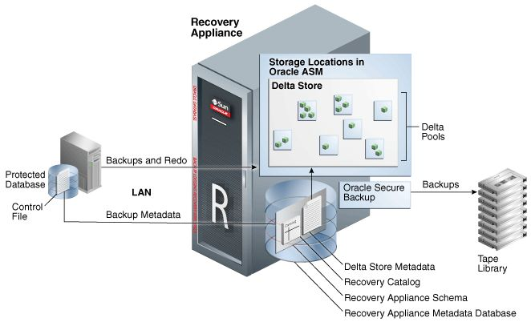

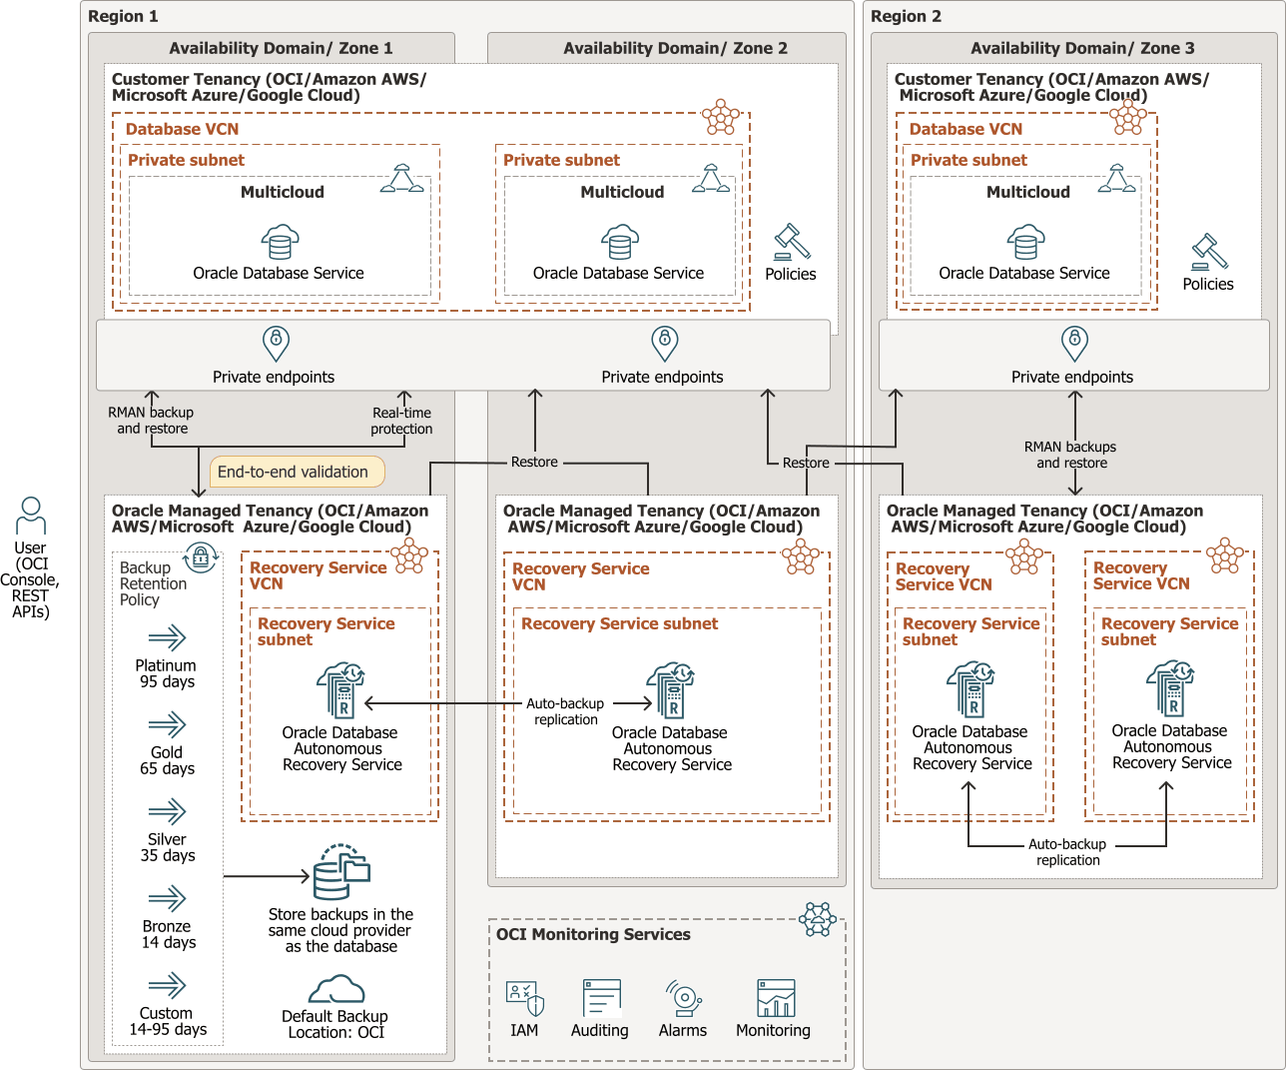

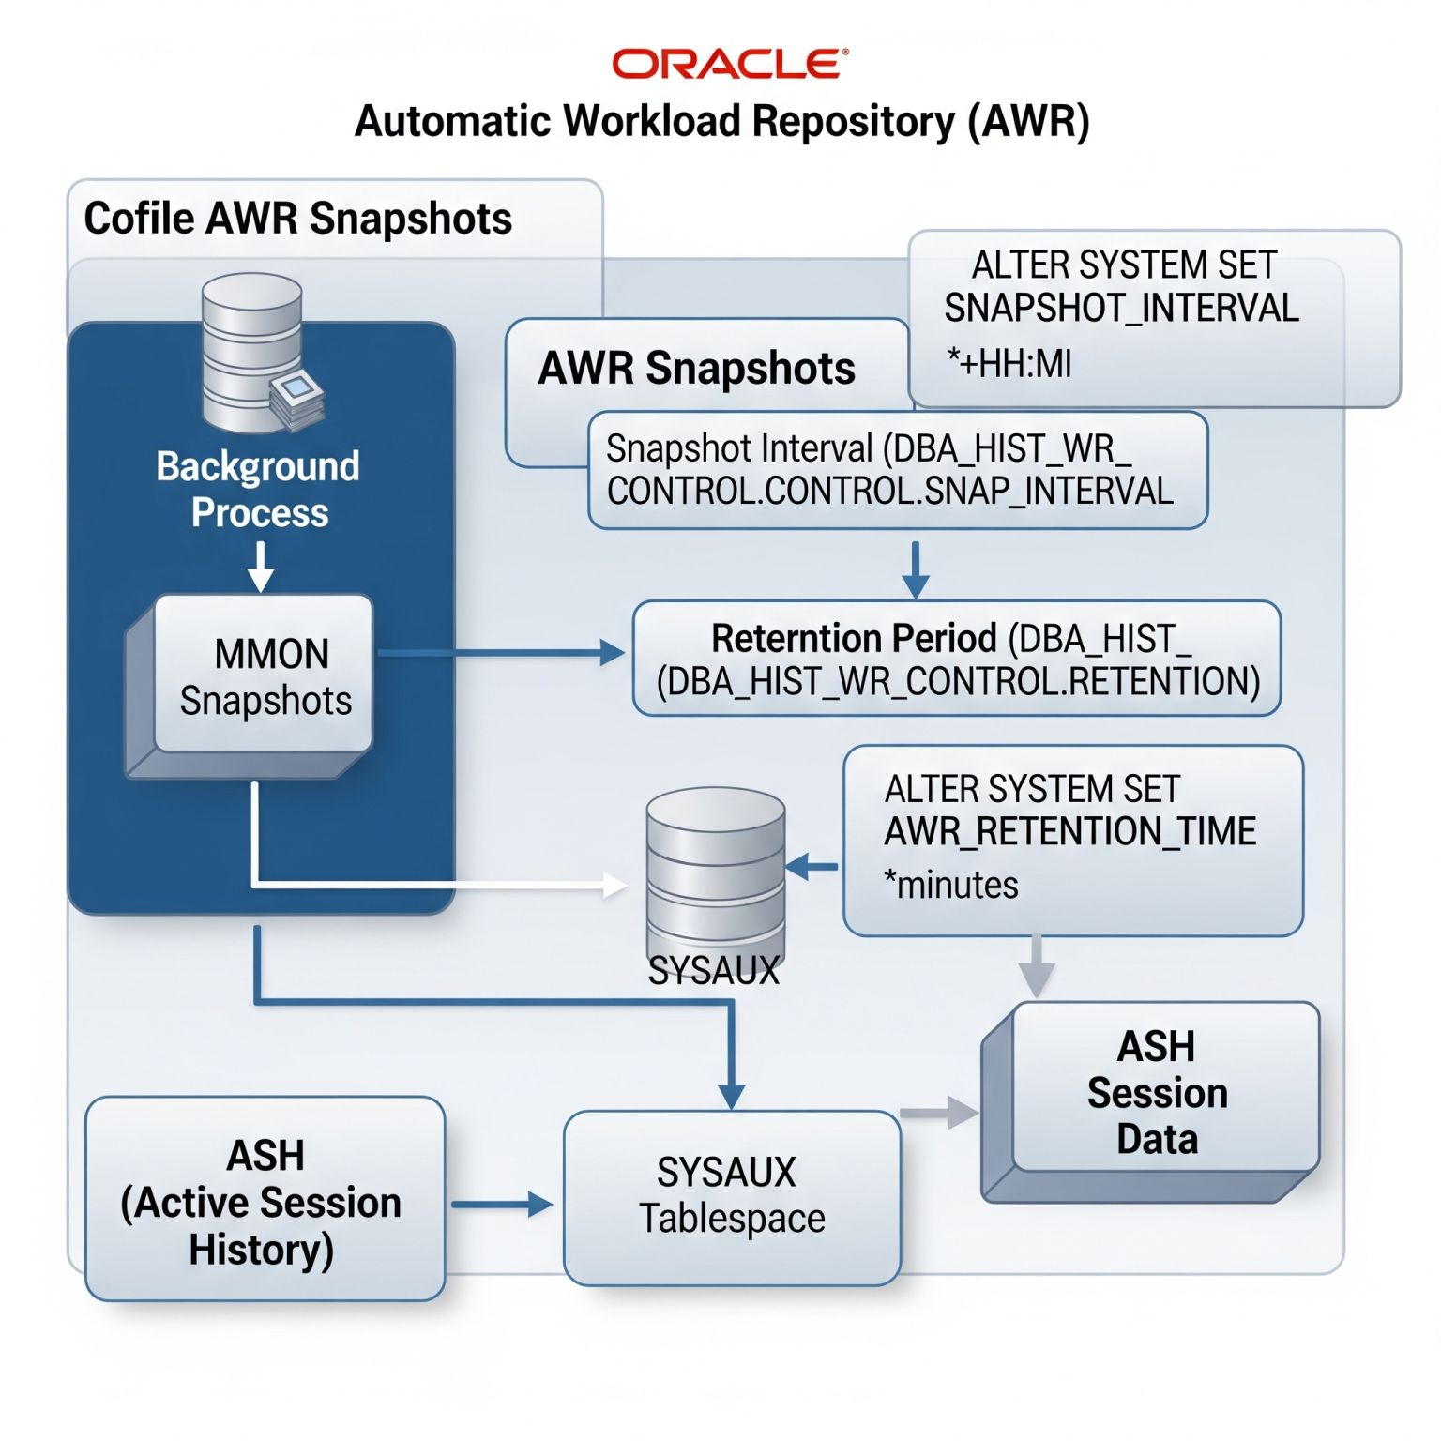

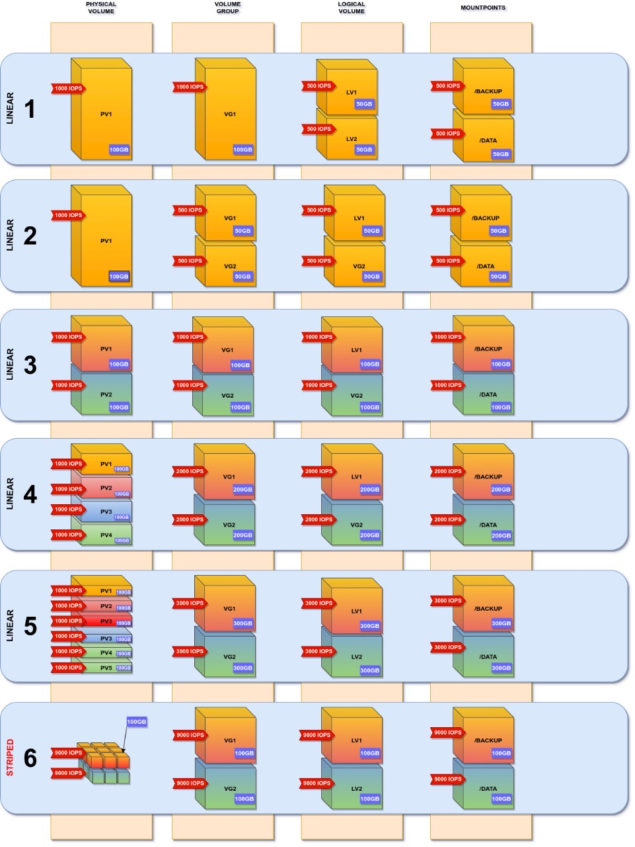

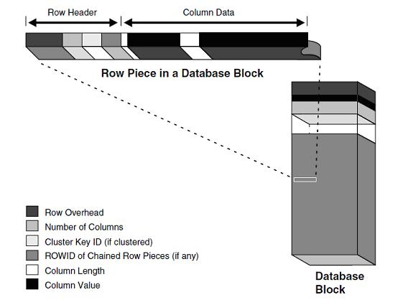

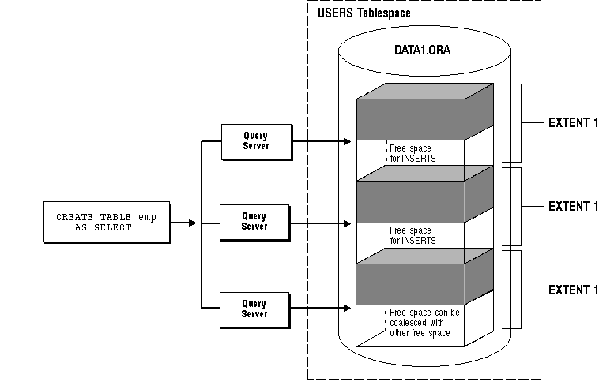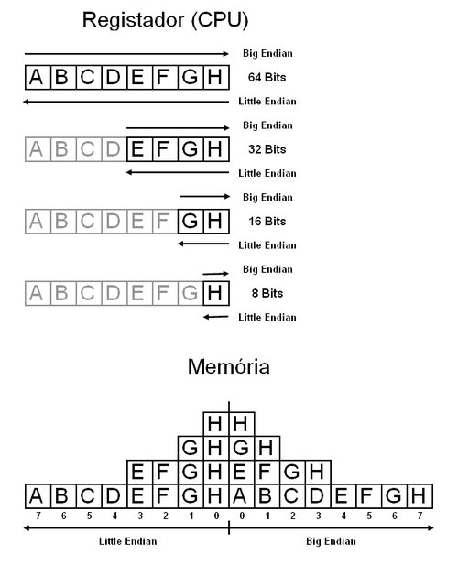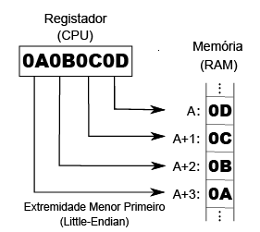

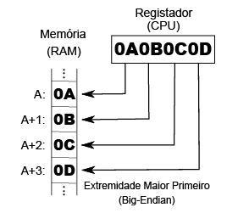

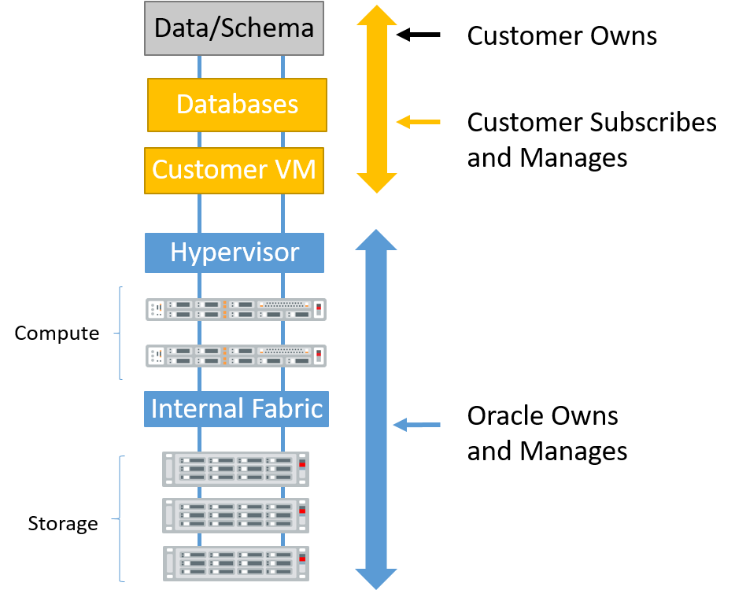


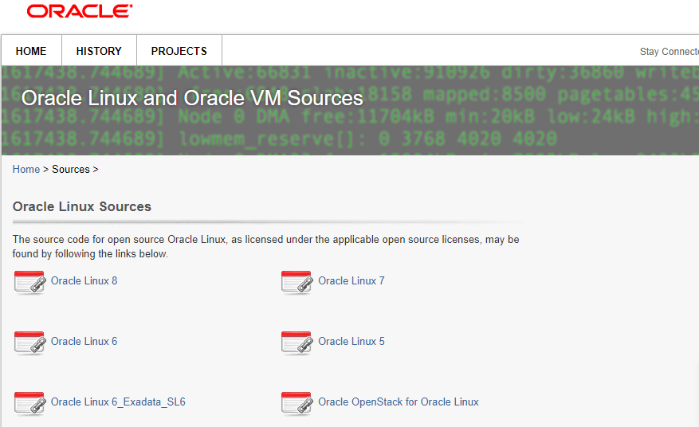
https://oss.oracle.com/sources/
https://linux.oracle.com/ords/f?p=101:101::::::

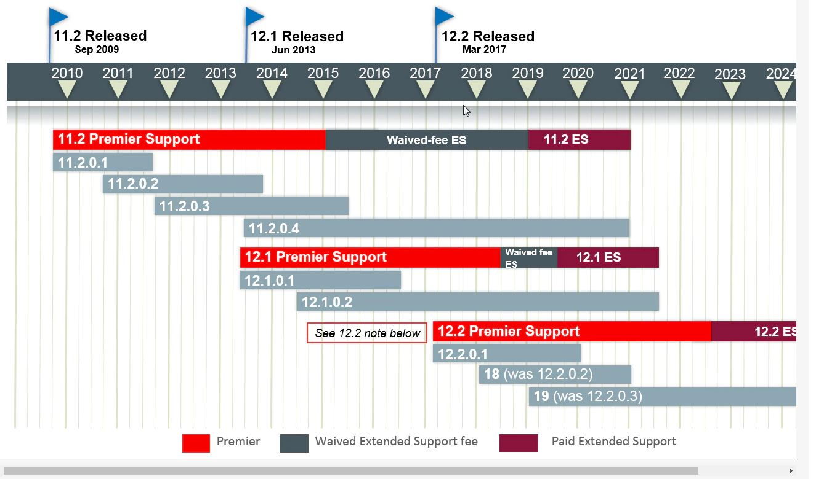
1. vCPU
AWS, Microsoft and Google use vCPU as compute performance unit. Each vCPU is defined as a hyperthread of an Intel Xeon core. A standard Intel processor core with hyperthreading enabled has 2 threads.
As described on picture above, one vCPU is equivalent to a single thread. Threads are not dedicated to VMs in standard configurations which is the key difference to Oracle metric - OCPU.
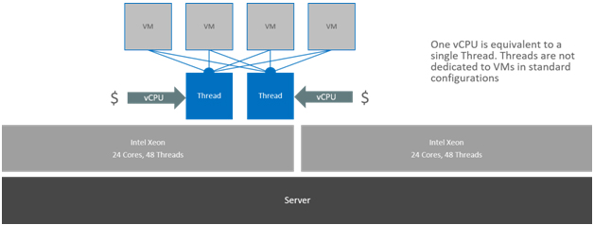
2. OCPU
Oracle Cloud Infrastructure measure for compute. An OCPU is defined as the CPU capacity equivalent of one physical core of an Intel Xeon processor with hyper threading enabled, or one physical core of an Oracle SPARC processor.
For Intel Xeon processor each OCPU corresponds to two hardware execution threads, known as vCPUs. For Oracle SPARC processors, one OCPU corresponds to eight hardware execution threads, also known as vCPUs.
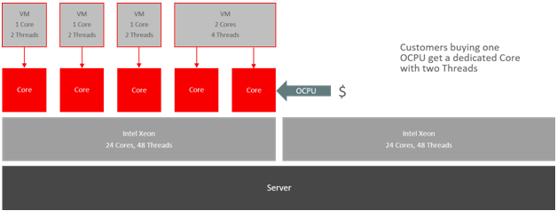
As described on picture above, customers buying one OCPU get a dedicated physical core with two threads.
3. Examples
Now let's compare OCPU and vCPU on some real OCI shapes.
Bare Metal instances:
BM.Standard2.52 shape - dedicated two socket Oracle x86 server powered by customized processor Intel Xeon 2.0 GHz Platinum 8167M. Server contains 52 physical cores (52 OCPU) in total. The equivalent to 52 OCPUs would be 104 vCPU (threads).
Virtual Machine instances:
VM.Standard1.1 shape - virtual machine powered by processor Intel Xeon 2.3 GHz E5-2699 v3. Processor contains 18 physical cores (18 OCPU) and in this specific shape, the customer is provisioned with 1 physical core (OCPU). The equivalent to 1 OCPU would be 2 threads.
To sum it up, when comparing offers or just talking to different providers, better use measure "thread" instead of "core", "processor" or "CPU".
SUPERCLUTER ARCHITECTURE:

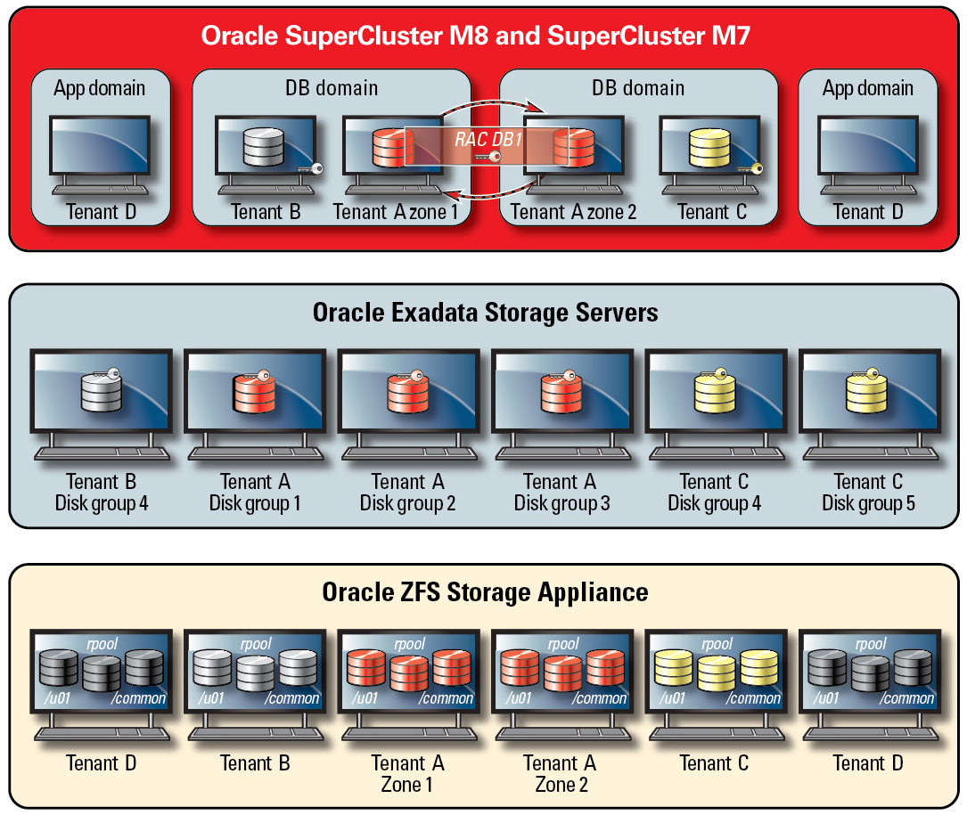
ACCESS CONTROL:

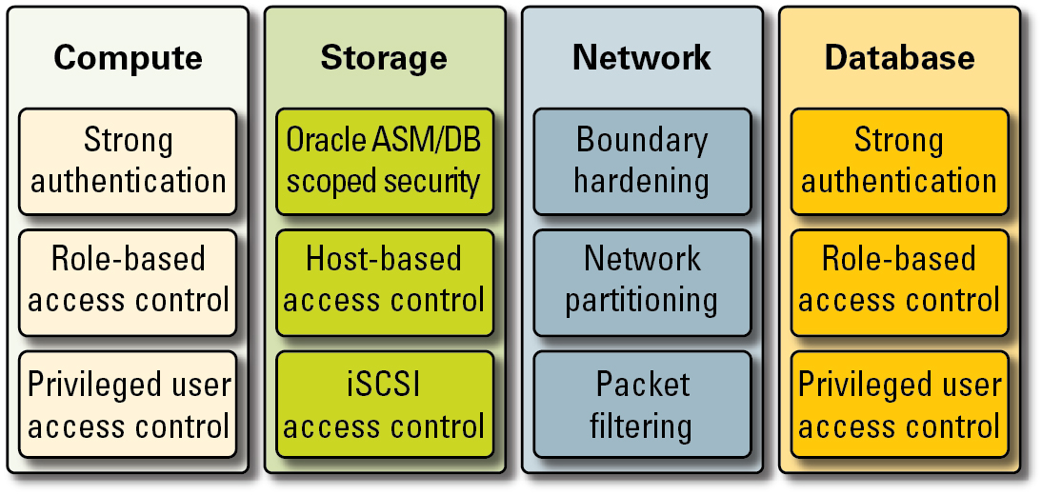

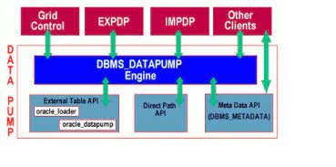

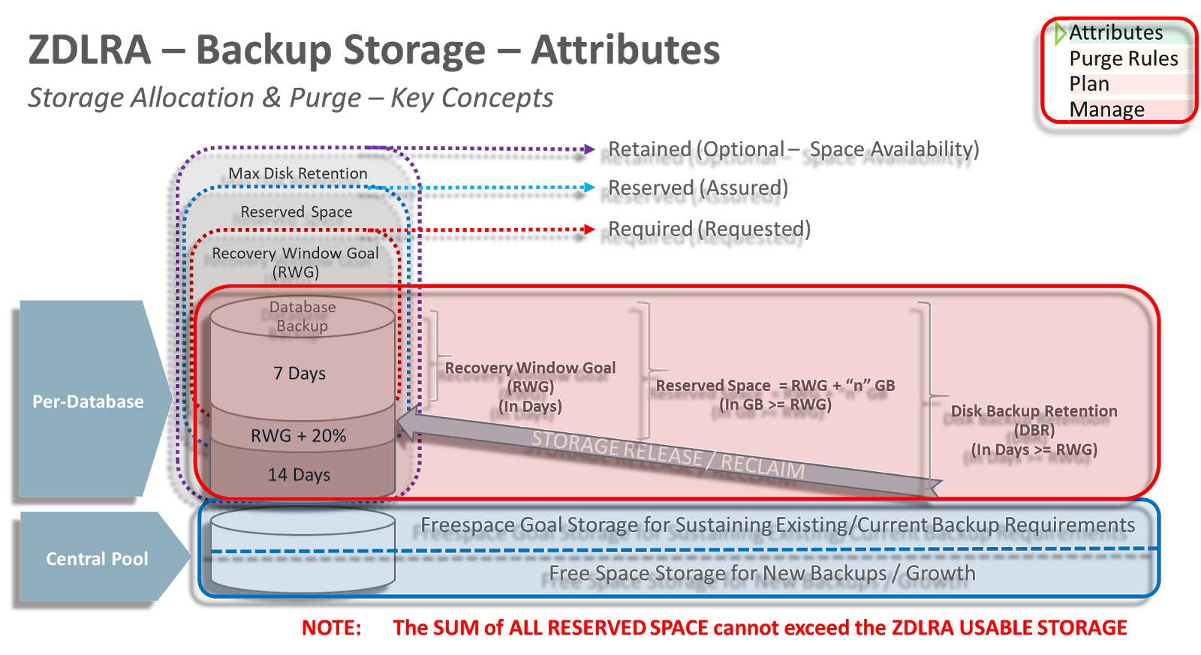

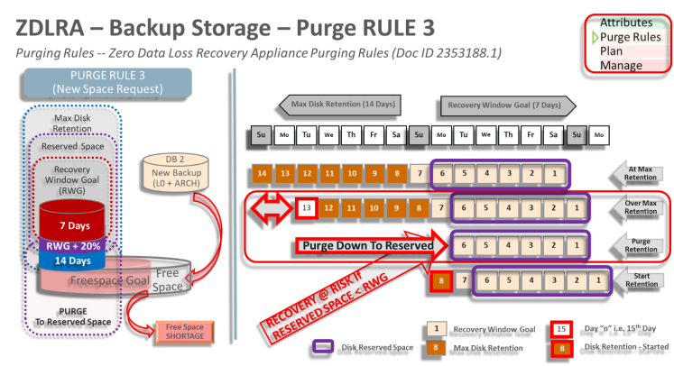

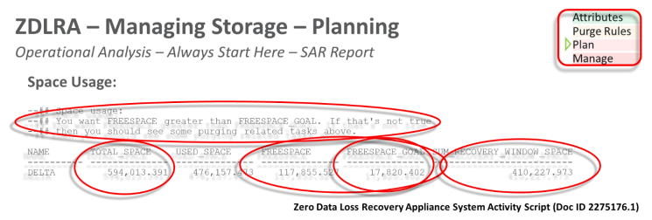

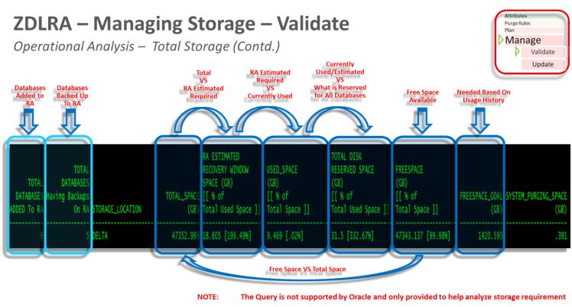

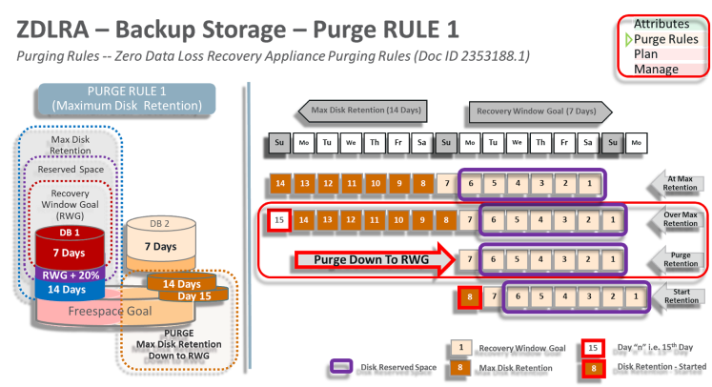

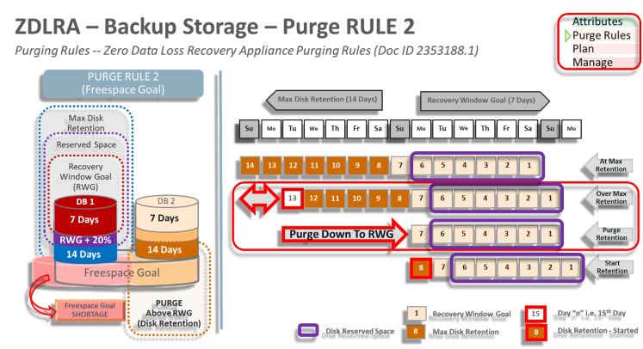

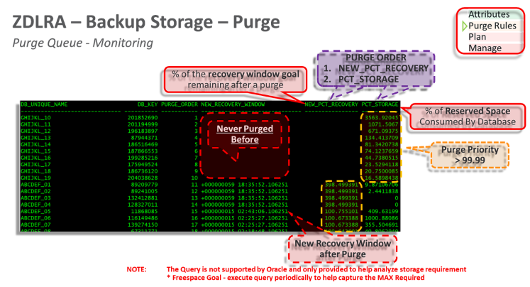

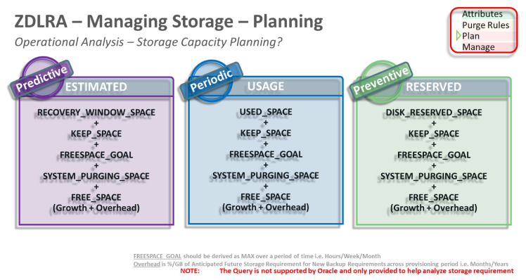

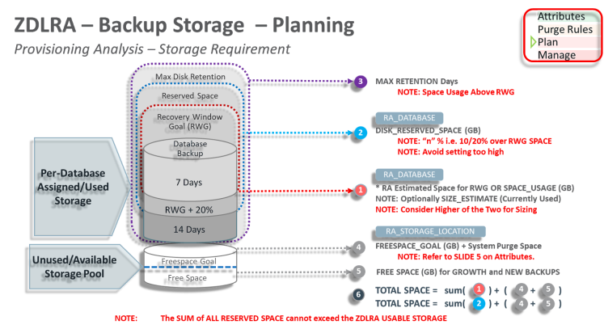

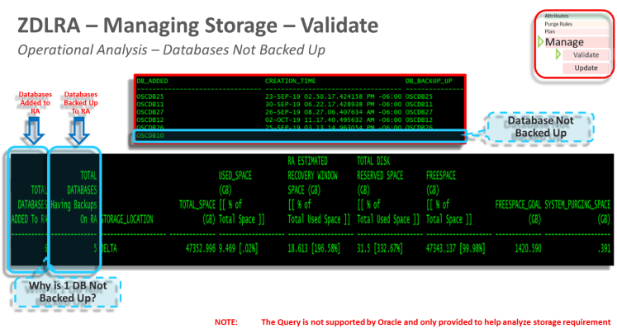

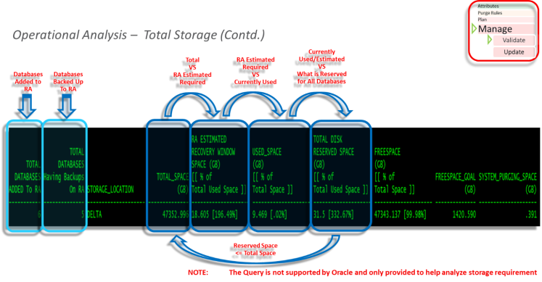

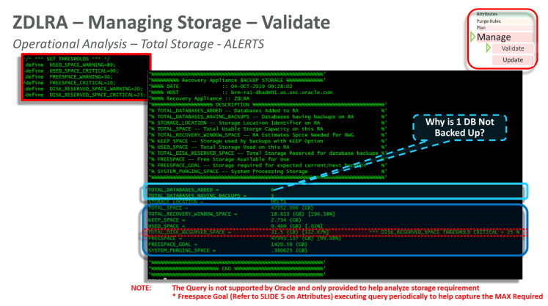

General Background Processes.
Acronym
Process Name
Description
SMON
System Monitor Process
Performs recovery after instance failure and monitors temporary segments and extents.
PMON
Process Monitor
Recovers failed process resources. If Shared Server architecture is used, PMON monitors and restarts any failed dispatcher or server processes.
LGWR
Log Writer Process
Writes the log buffer out to the redo logs.
DBWn
Database Writer Process
Writes dirty buffers from the buffer cache to the data files. Possible processes include DBW0–DBW9 and DBWa–DBWz
CKPT
Checkpoint Process
Writes checkpoint information to control files and data file headers.
ARCn
Archiver Process
Writes filled redo logs to the archive log location(s). Possible processes include ARC0–ARC9 and ARCa–ARCt.
DIA0
Diagnostic Process
Responsible for hang detection and deadlock resolution. Triggers DIAG to perform diagnostic tasks.
CJQ0
Job Queue Coordinator Process
Spawns slave processes (Jnnn) to execute jobs in the queue
MMAN
Memory Manager Process
Serves as the SGA Memory Broker and coordinates the sizing of the memory components
MMNL
Manageability Monitor Lite Process
Performs frequent and lightweight manageability related tasks, such as session history, capture and metrics computation.
MMON
Manageability Monitor Process
Collects statistics for the Automatic Workload Repository.
RECO
Recoverer Process
Resolves failures involving distributed transactions.
Advanced Queuing Background Processes
Acronym
Process Name
Description
Qnnn
AQ Server Class Process
Processes messaged in the Streams AQ queue. Spawned by QMNC.
QMNC
AQ Coordinator Process
Monitors message queues. Spawns Qnnn Processes
Automatic Storage Management Background Processes
Acronym
Process Name
Description
ARBn
ASM Rebalance
Process
Rebalances data extents across the ASM file systems. Possible processes are ARB0 – ARB9 and ARBA.
ASMB
ASM Background Process
Communicates with the Automatic Storage Management instance.
DSKM
Slave Diskmon Process
Acts as conduit between RDBMS and ASM instances and the Master Diskmon daemon to communicate I/O Fencing Information, I/O Resource Manager Plans, and Transaction Commit Cache information to SAGE storage. If no SAGE storage is used, the slave diskmon process will exit silently after startup of the instance.
GMON
ASM Disk Group Monitor Process
Maintains disk membership in ASM disk groups.
MARK
Mark AU for Resynchronization Coordinator Process
Marks ASM Allocation Units as stale following a missed write to an offline disk.
RBAL
ASM Rebalance
Master Process
Coordinates rebalance activity for disk groups in an Automatic Storage Management instance. Performs global opens on Automatic Storage Management disks.
DRnn
ASM Disk
Resynchronization
Slave Process
Resynchronizes the contents of an offline disk. When a disk online SQL command is issued on a disk or disks that are offline, ASM spawns DRnn. Depending on the load, more than one slave may be spawned.
Data Guard Background Processes
Acronym
Process Name
Description
MRP0
Managed Standby Recovery Process
coordinates the read and apply process of redo in a physical standby database.

RFS

Remote File Server

is responsible for receiving the redo data, which is sent by the primary database to the standby database
LSP0
Logical Standby Coordinator Process
Assigns transactions to different Data Guard appliers and coordinates among them to ensure that dependencies between transactions are honored.
LSP1
Logical Standby Dictionary Build Process
Builds the data dictionary for the Logical Standby.
LSP2
Logical Standby Set Guard Process
Maintains Guard Standby information for the Logical Standby.
DMON

Data Guard Broker Monitor Process

runs on every instance in a Data Guard broker configuration. It communicates with local database and DMON processes of the remote databases. The broker-related requests and the monitoring information are transferred on this communication channel.

FSFP

Data Guard broker fast-start failover pinger process

is used for the management of fast-start failover status

RSM0
Data Guard Broker
Worker Process
Used by the DMON process to manage and
monitor the database.
Real Application Clusters Background Processes
Acronym
Process Name
Description
ACMS
Atomic Control File to Memory Server Process
Contributes to ensuring a distributed SGA memory update is either globally omitted on success or globally aborted in the event of a failure in an Oracle RAC environment.
GTXn
Global Transaction Process
Provides transparent support for XA global transactions in an Oracle RAC environment. The database auto tunes the number of these process based on the workload of XA global transactions. Possible processes are GTX0–GTX9 and GTXa– GTXj
LCK0
Instance Enqueue Background Process
Manage the global enqueued requests and the cross-instance broadcast. Handles all requests for resources other than data blocks.
LMD0
Global Enqueue Service Daemon 0 Process
Manages enqueue manager service requests for Global Cache Service enqueues to control access to global enqueues and resources. The LMD0 process also handles deadlock detection and remote enqueued requests. Remote resource requests are the requests originating from another instance.
LMON
Global Enqueue Service Monitor Process
Monitors the entire cluster to manage the global enqueues and the resources. Manages instance and process failures and the associated recovery for the Global Cache Service (GCS) and Global Enqueue Service (GES). In particular LMON handles the part of recovery associated with global resources. LMON-provided services are also known as cluster group services (CGS).
LMSn
Global Cache Service Process
Handles remote Global Cache Service (GCS) messages. The number of LMS processes varies depending on the amount of messaging traffic among nodes in the cluster.
PING
Interconnect Latency Measurement Process
Assesses the latencies associated with communications for each pair of instances. Every few seconds, the process in one instance (INSTANCE_NUMBER value) sends two messages to each instance (TARGET_INSTANCE value). One message has a size of 500 bytes and the other has a size of 8 KB. The message is received by the PING process on the target instance and is immediately acknowledged. The time for the round-trip is measured and collected.
RMSn
Oracle RAC Management Process
Performs manageability tasks for Oracle RAC, such as creation of RAC-related resources when new instances are added to the clusters.
RSMN
Remote Slave Monitor Process
Manages background slave process creation and communication on remote instances.

